Social Story

Watch it grow
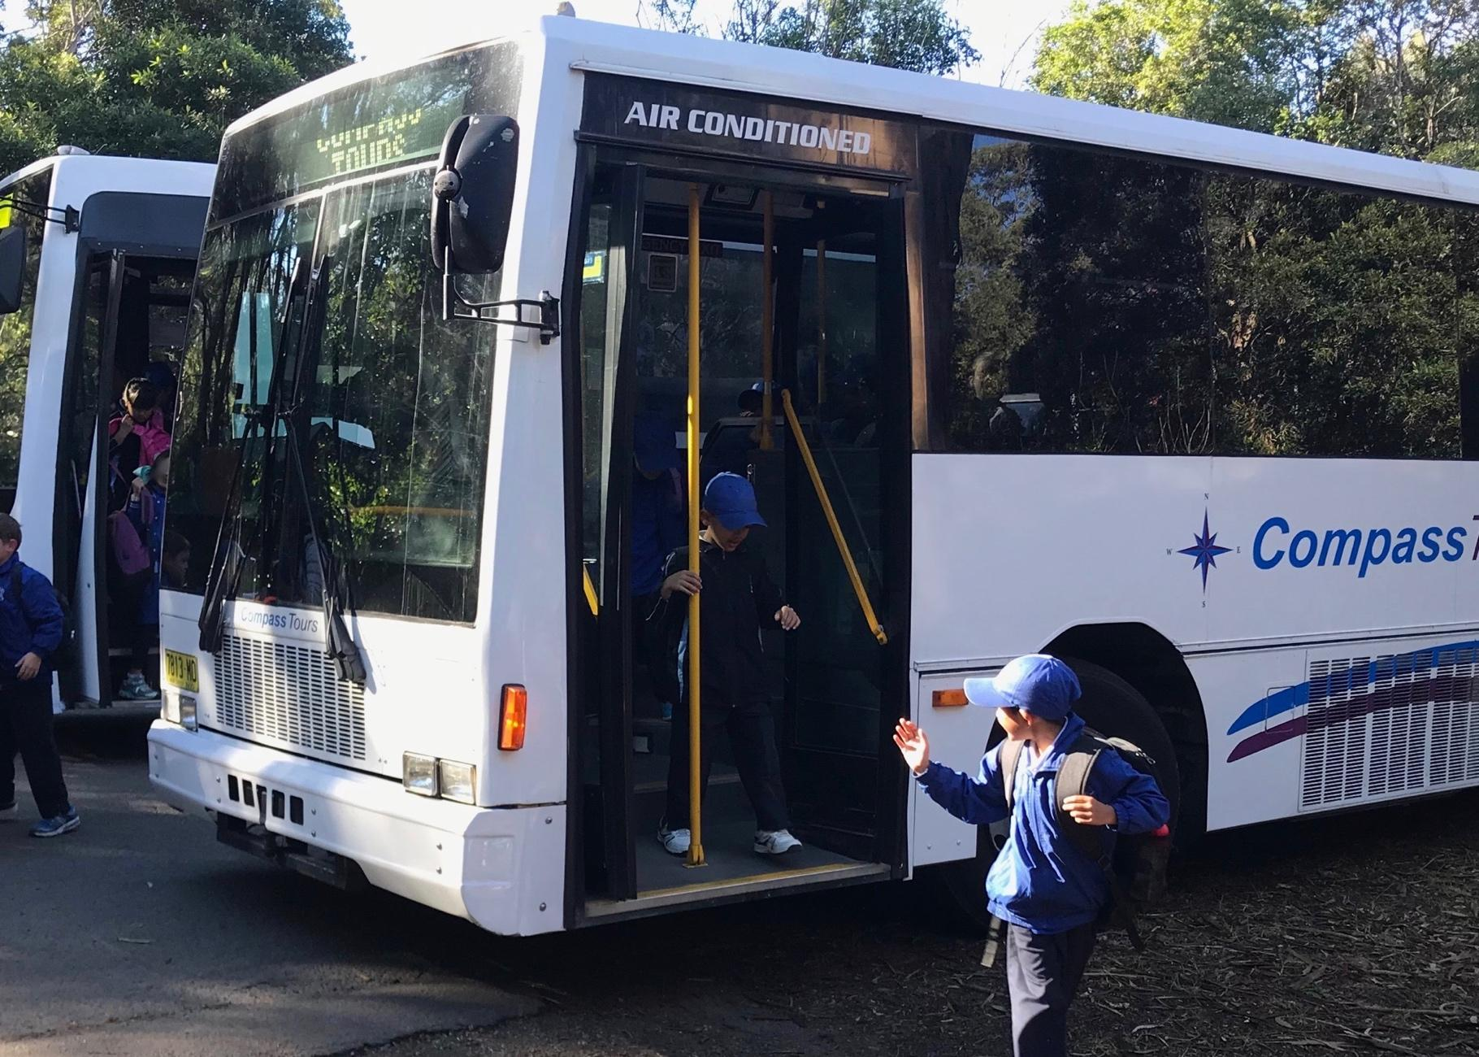
A bus will take you to the Field of Mars Reserve.

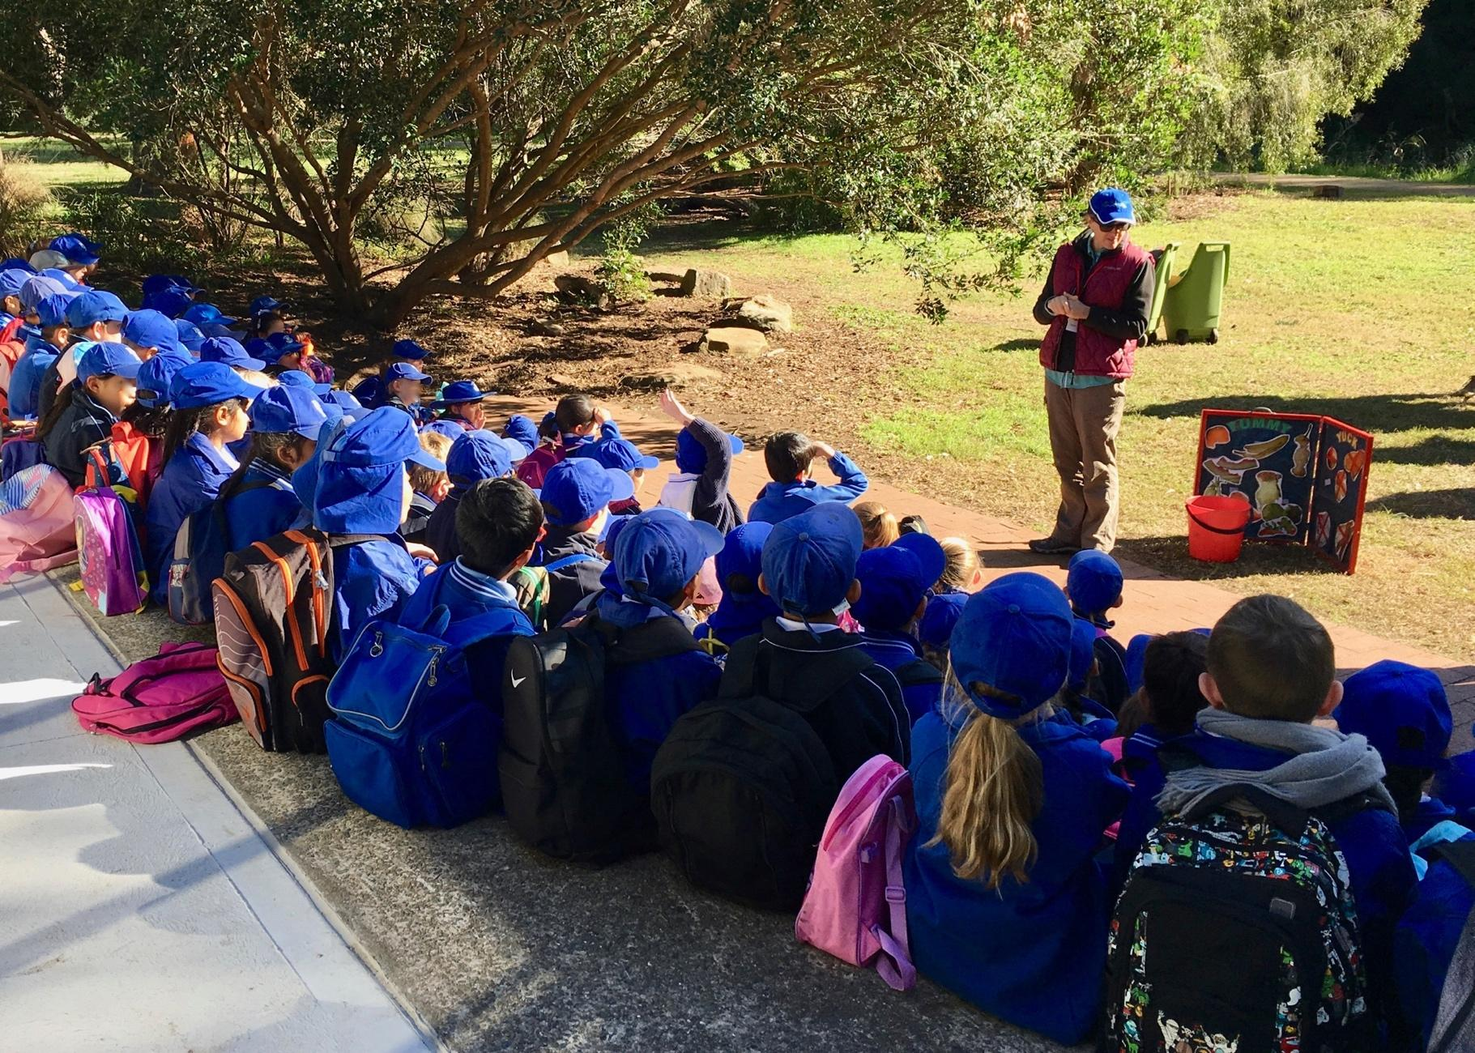
When you arrive, you will sit in the meeting area. The teachers will talk with you about your day. You will eat your morning tea.
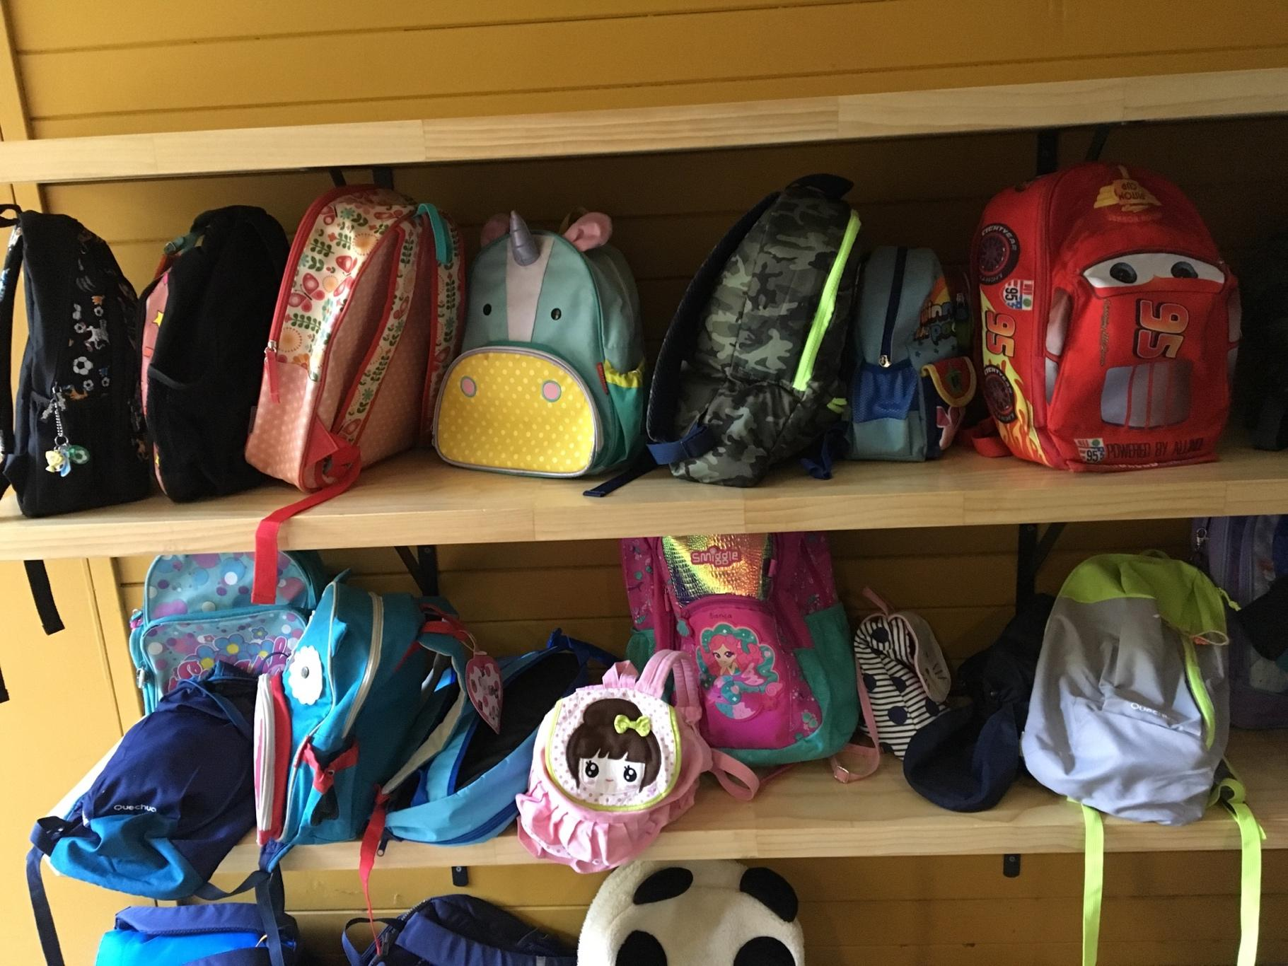
You will put your bag onto the shelves and go to the toilet before starting the activities. Your bag will be safe there.
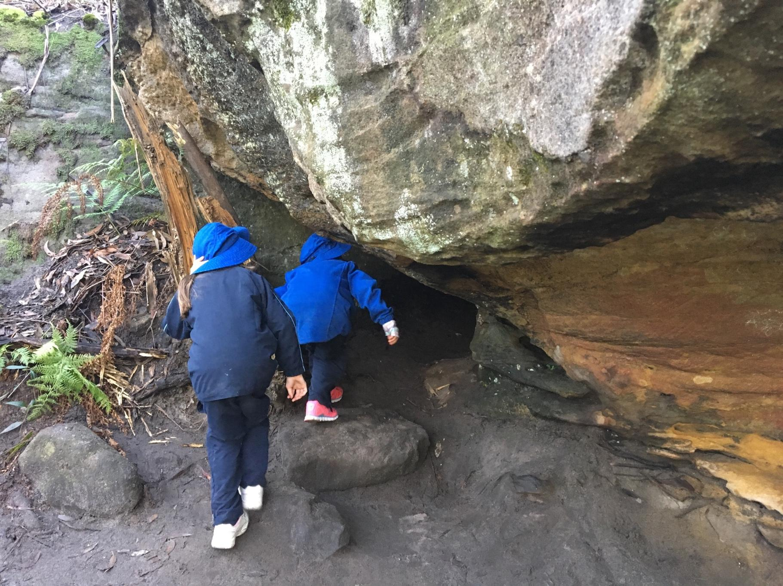

You will walk through the bushland and look closely at living things.

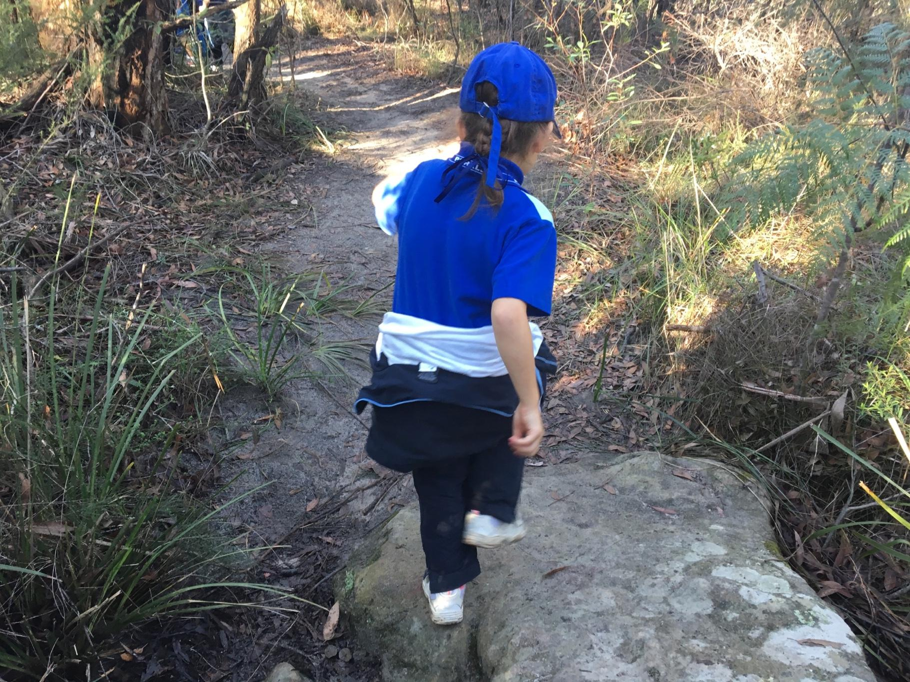
You will walk on bush tracks that have dirt and rocks.
When it has been raining the rocks can be slippery.
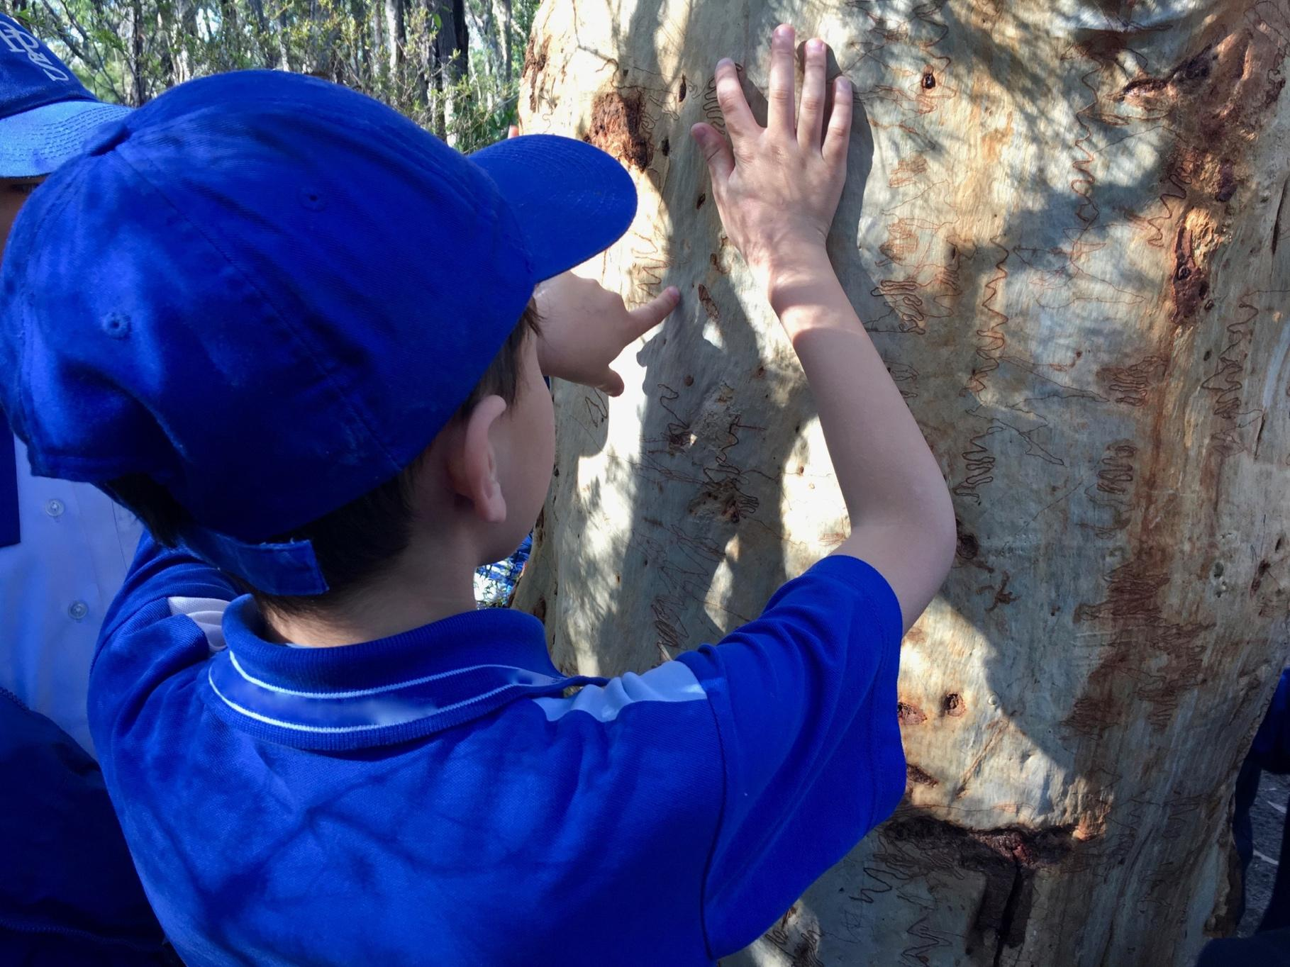
You will look, listen, touch and smell different things in the bushland.

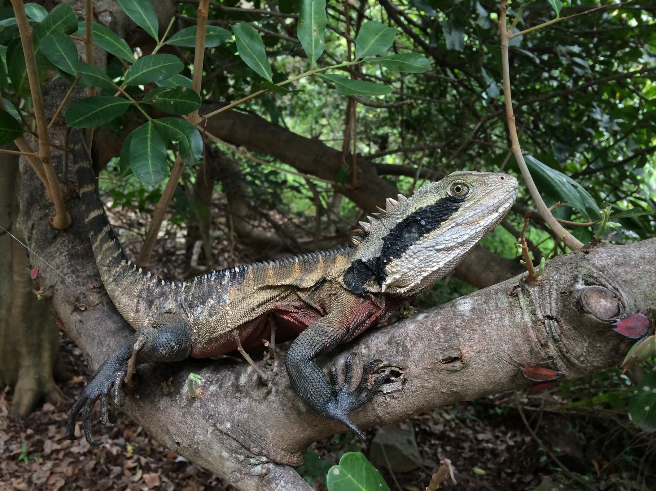
You might see some wildlife that lives in the bushland.
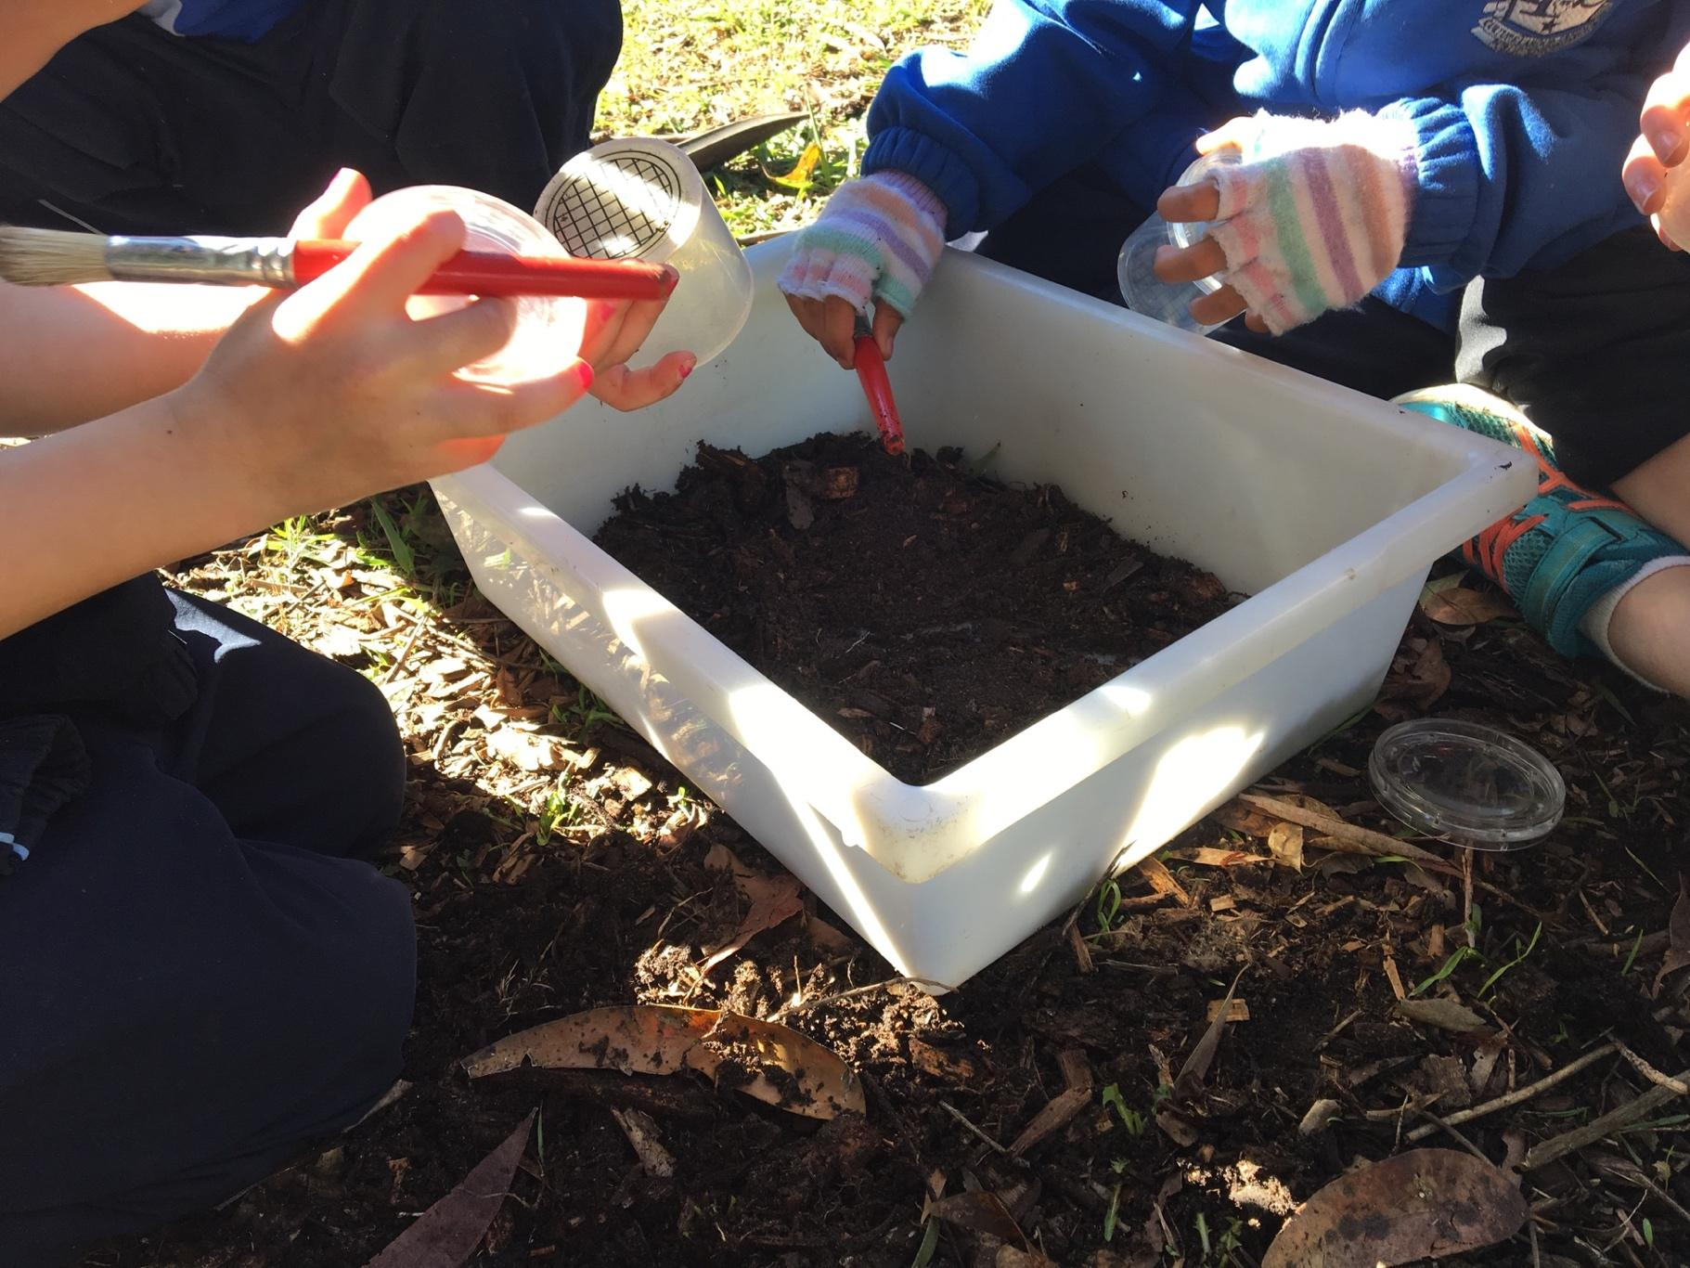
You will use equipment to look for invertebrates in the gardens around the classrooms.
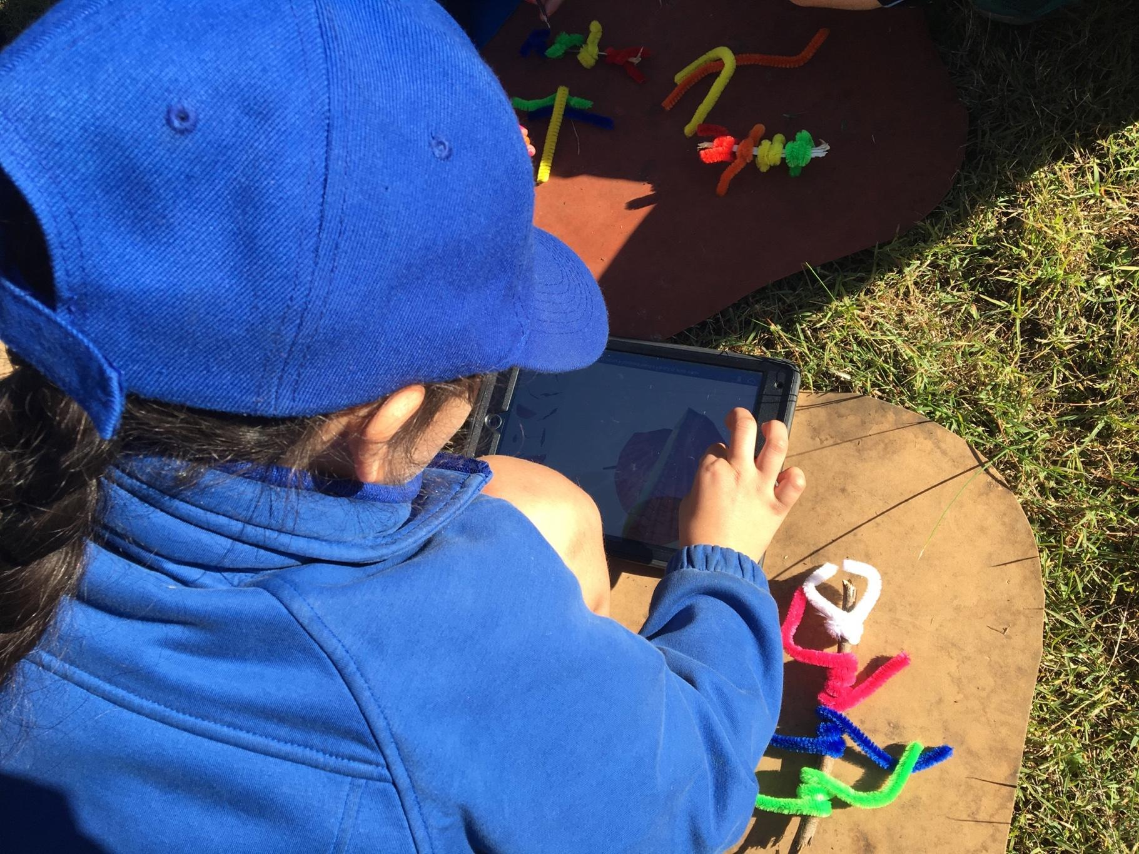
You will see a live spiny leaf insect. You will look at pictures of spiny leaf insects and then make one using a stick and bendy pipe cleaners.
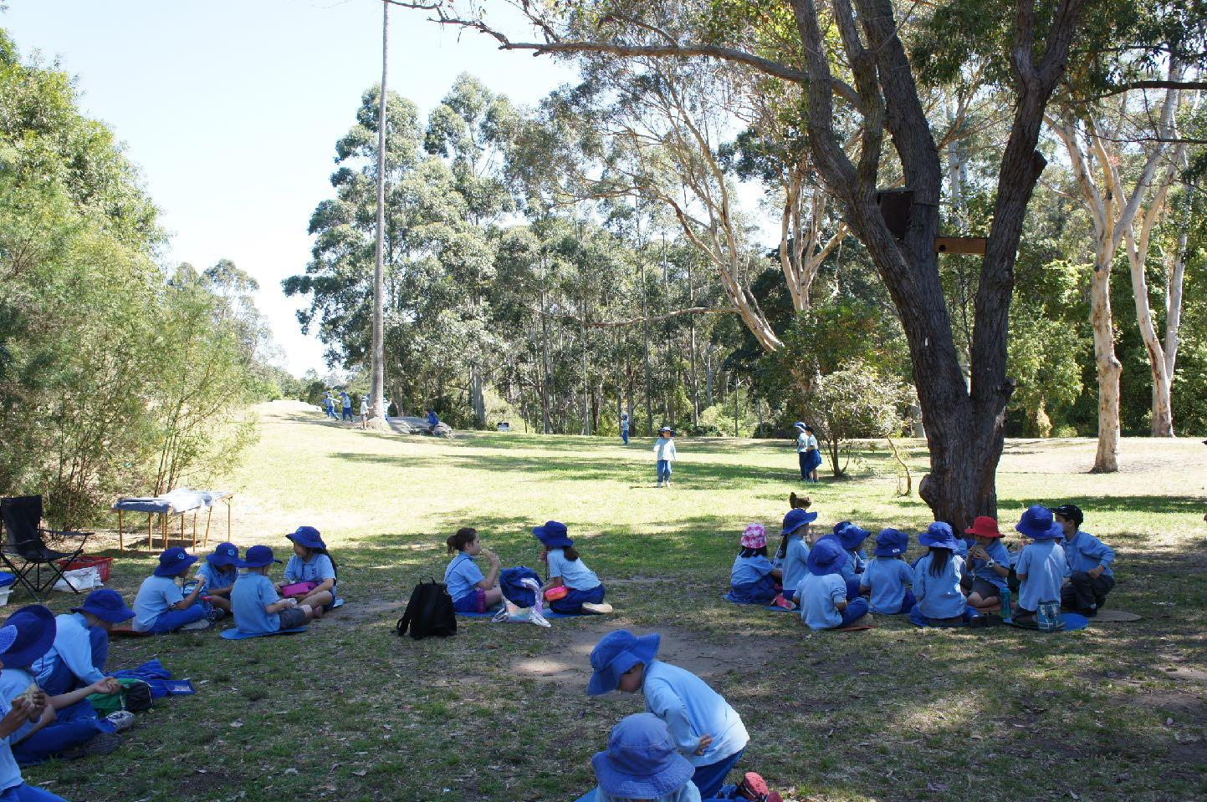
At lunch time you will sit on the grass to eat your lunch.
After eating time you will play on the grass.
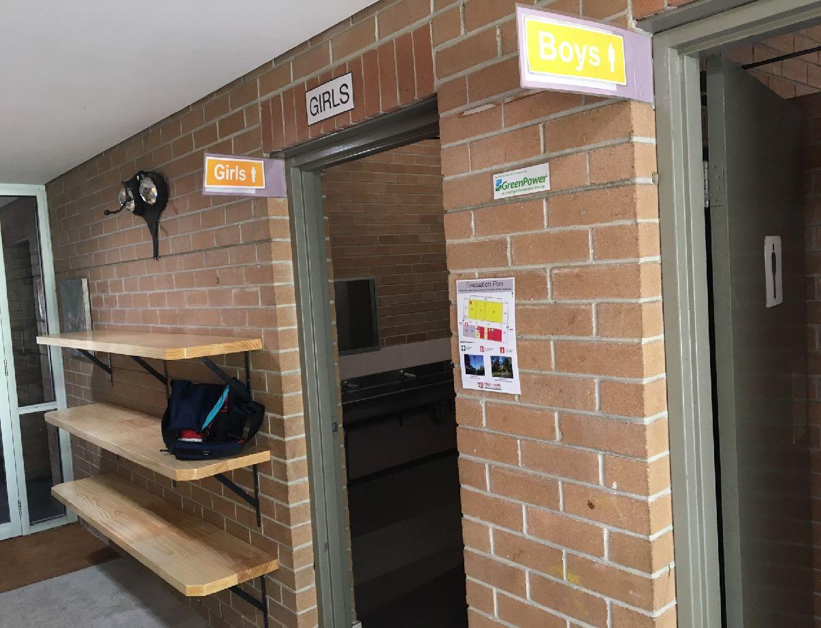
At the end of the day you will go to the toilet and collect your bag.
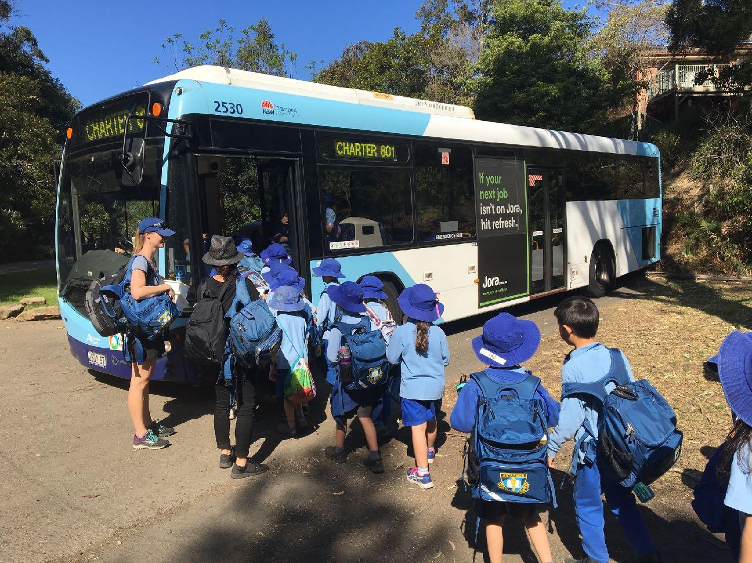
You will walk to the bus and it will take you back to school.

