Social Story

Teddy Bears Picnic
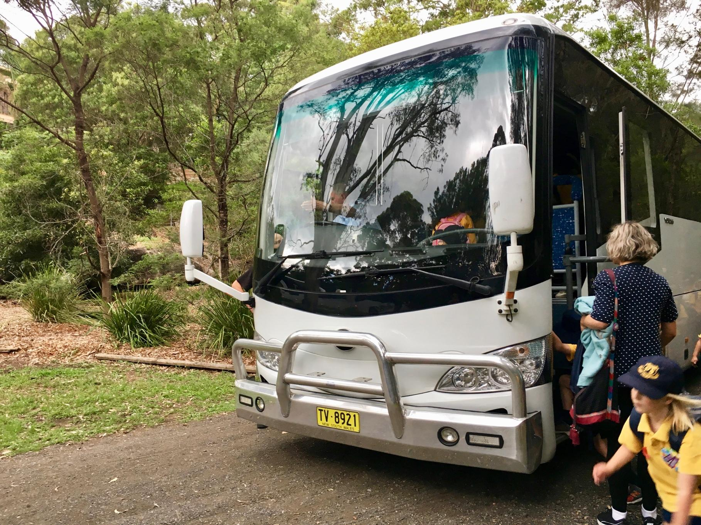
A bus will take you to the Field of Mars Reserve.
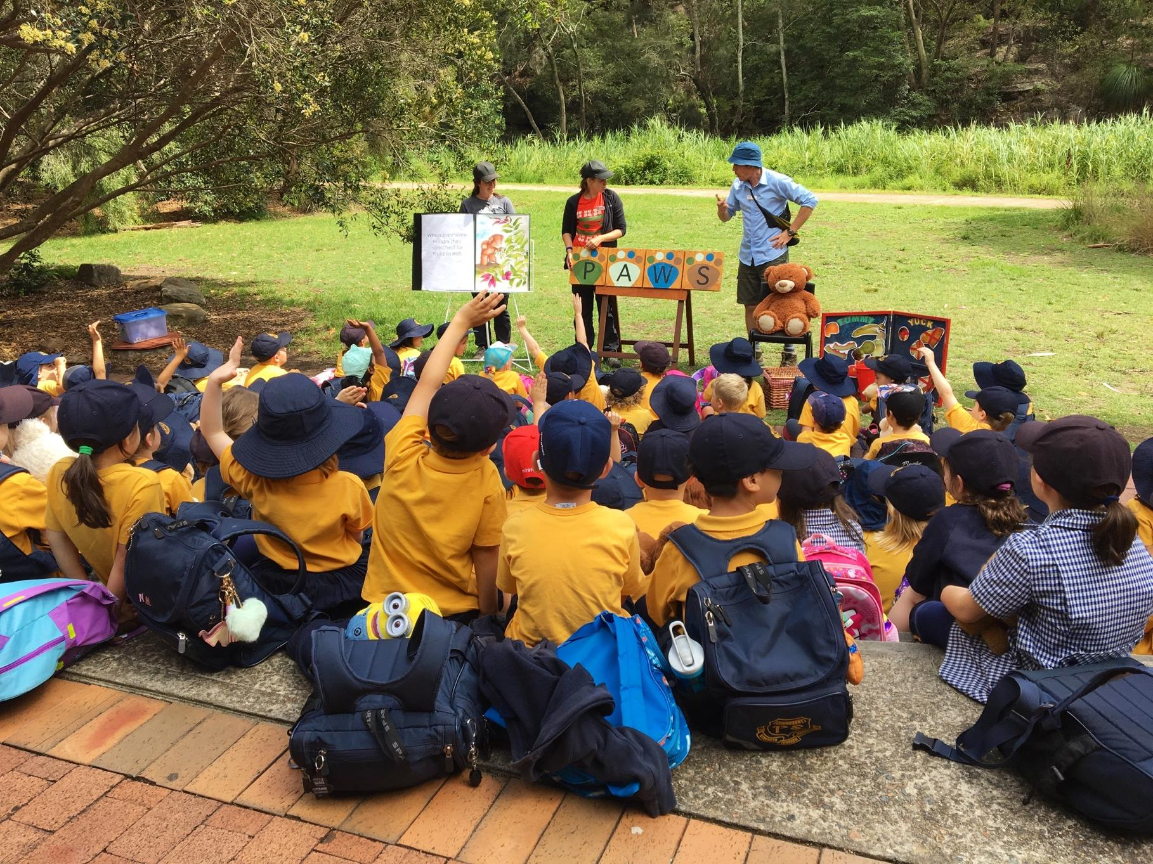
When you arrive, you will sit in the meeting area. The teachers will read a story and talk with you about your day. You will have your crunch and sip.
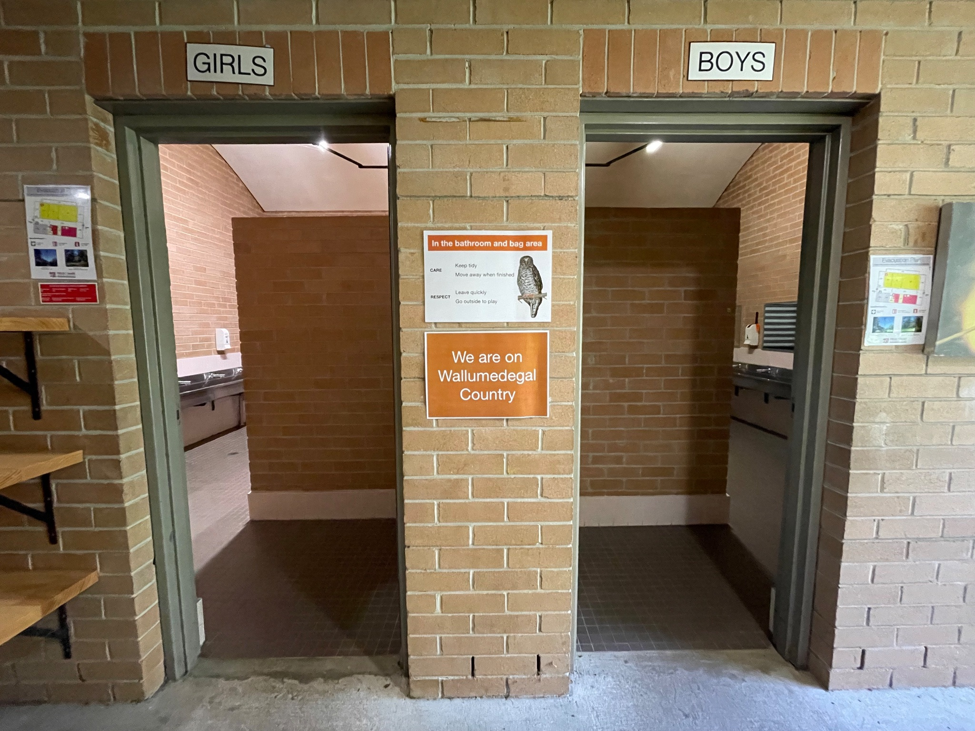
You will go to the toilet before starting the activities.
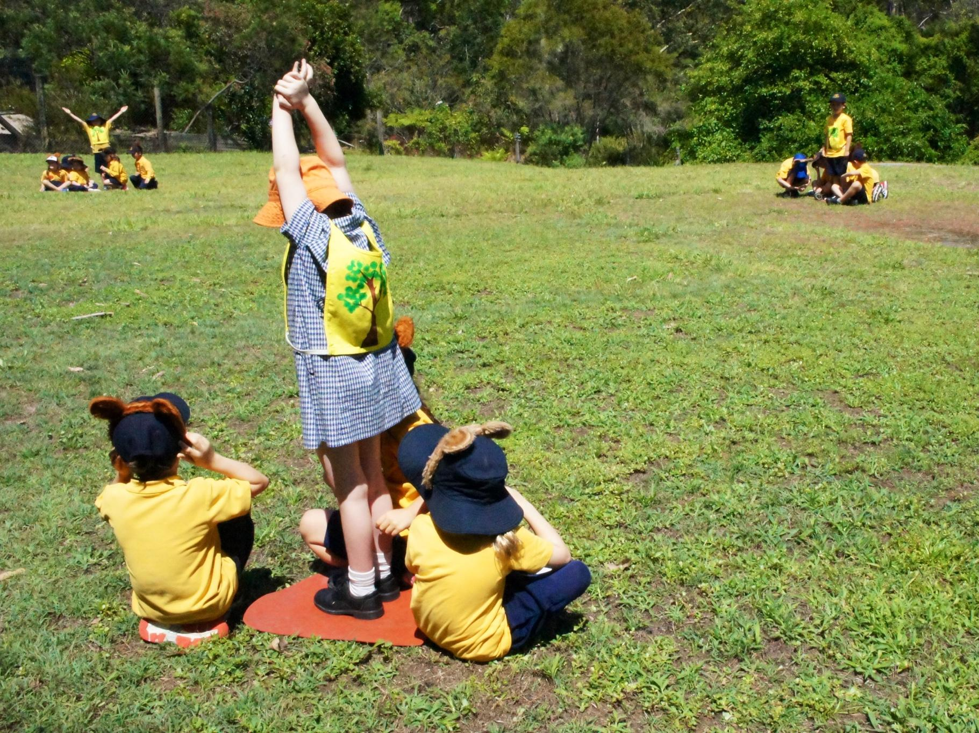
You will play some teddy bear games on the grass.
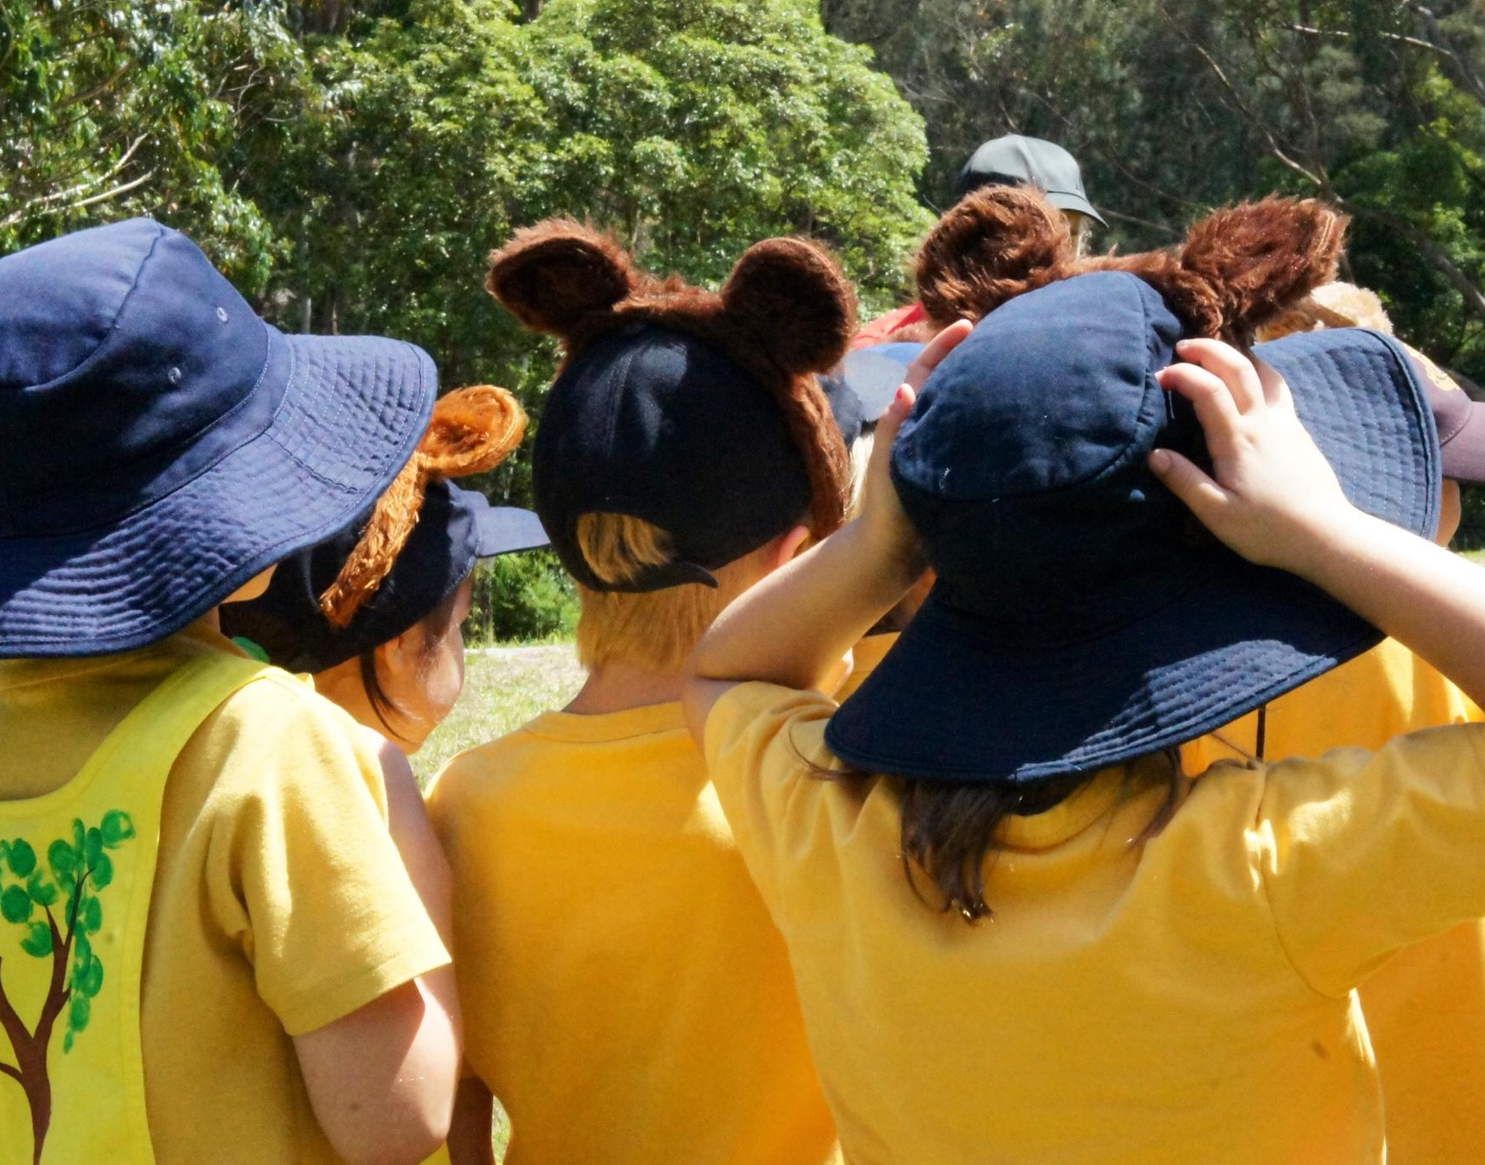
You might wear some teddy bear ears.
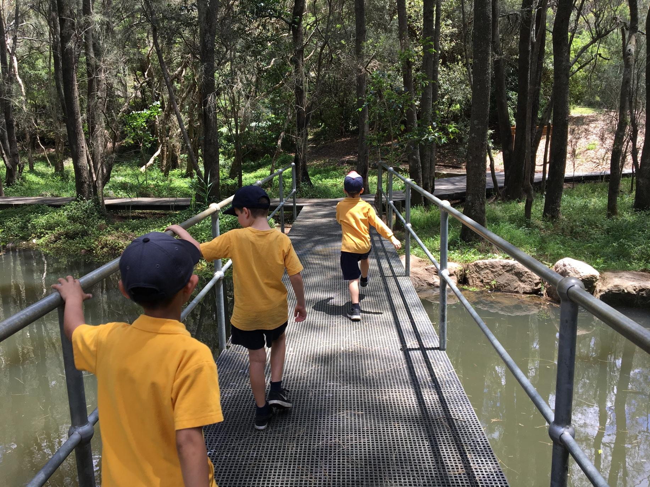
You will go on a bushwalk through the Field of Mars Reserve.
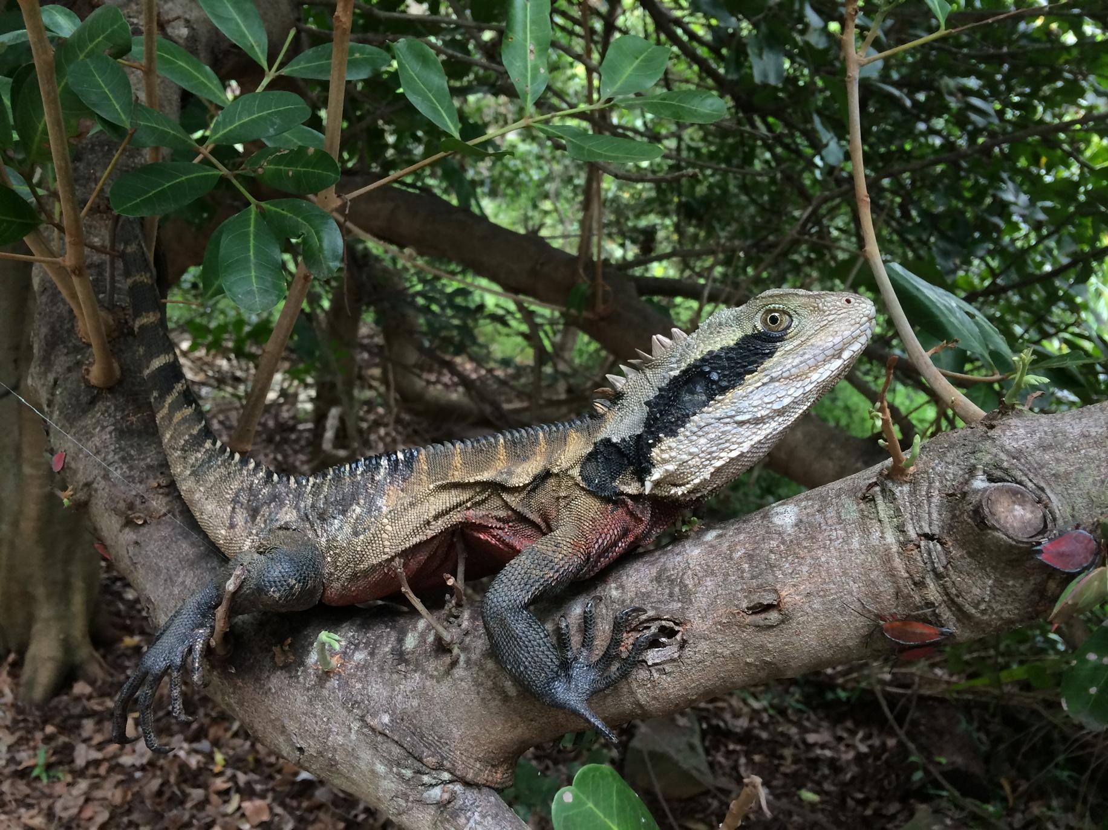
You might see some wildlife that lives in the bushland.
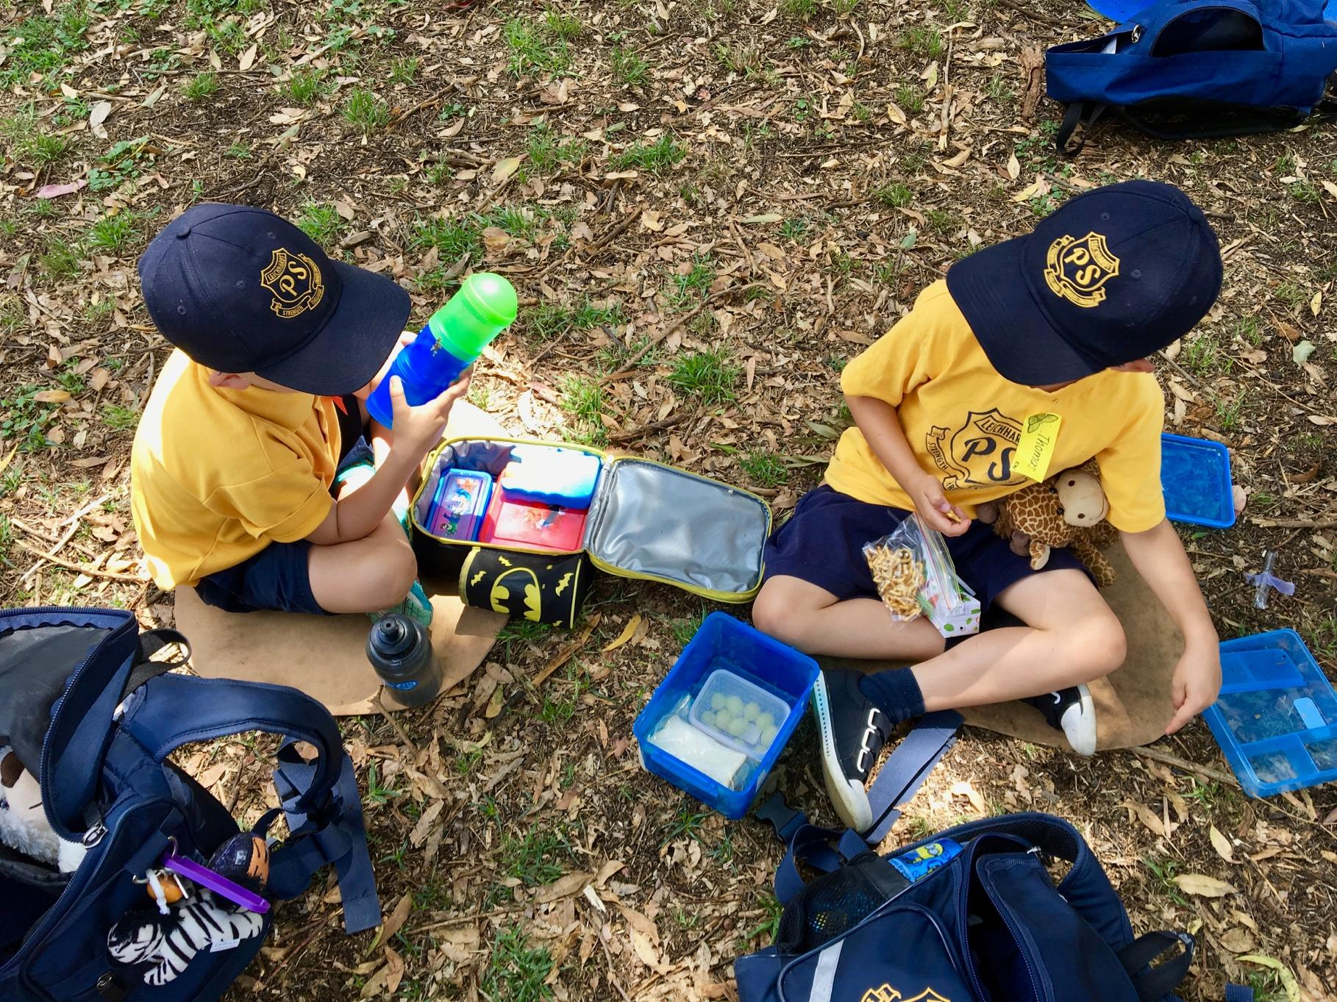
At recess you will sit on the grass beside the classrooms and have your morning tea. You will have a short play time on the grass.
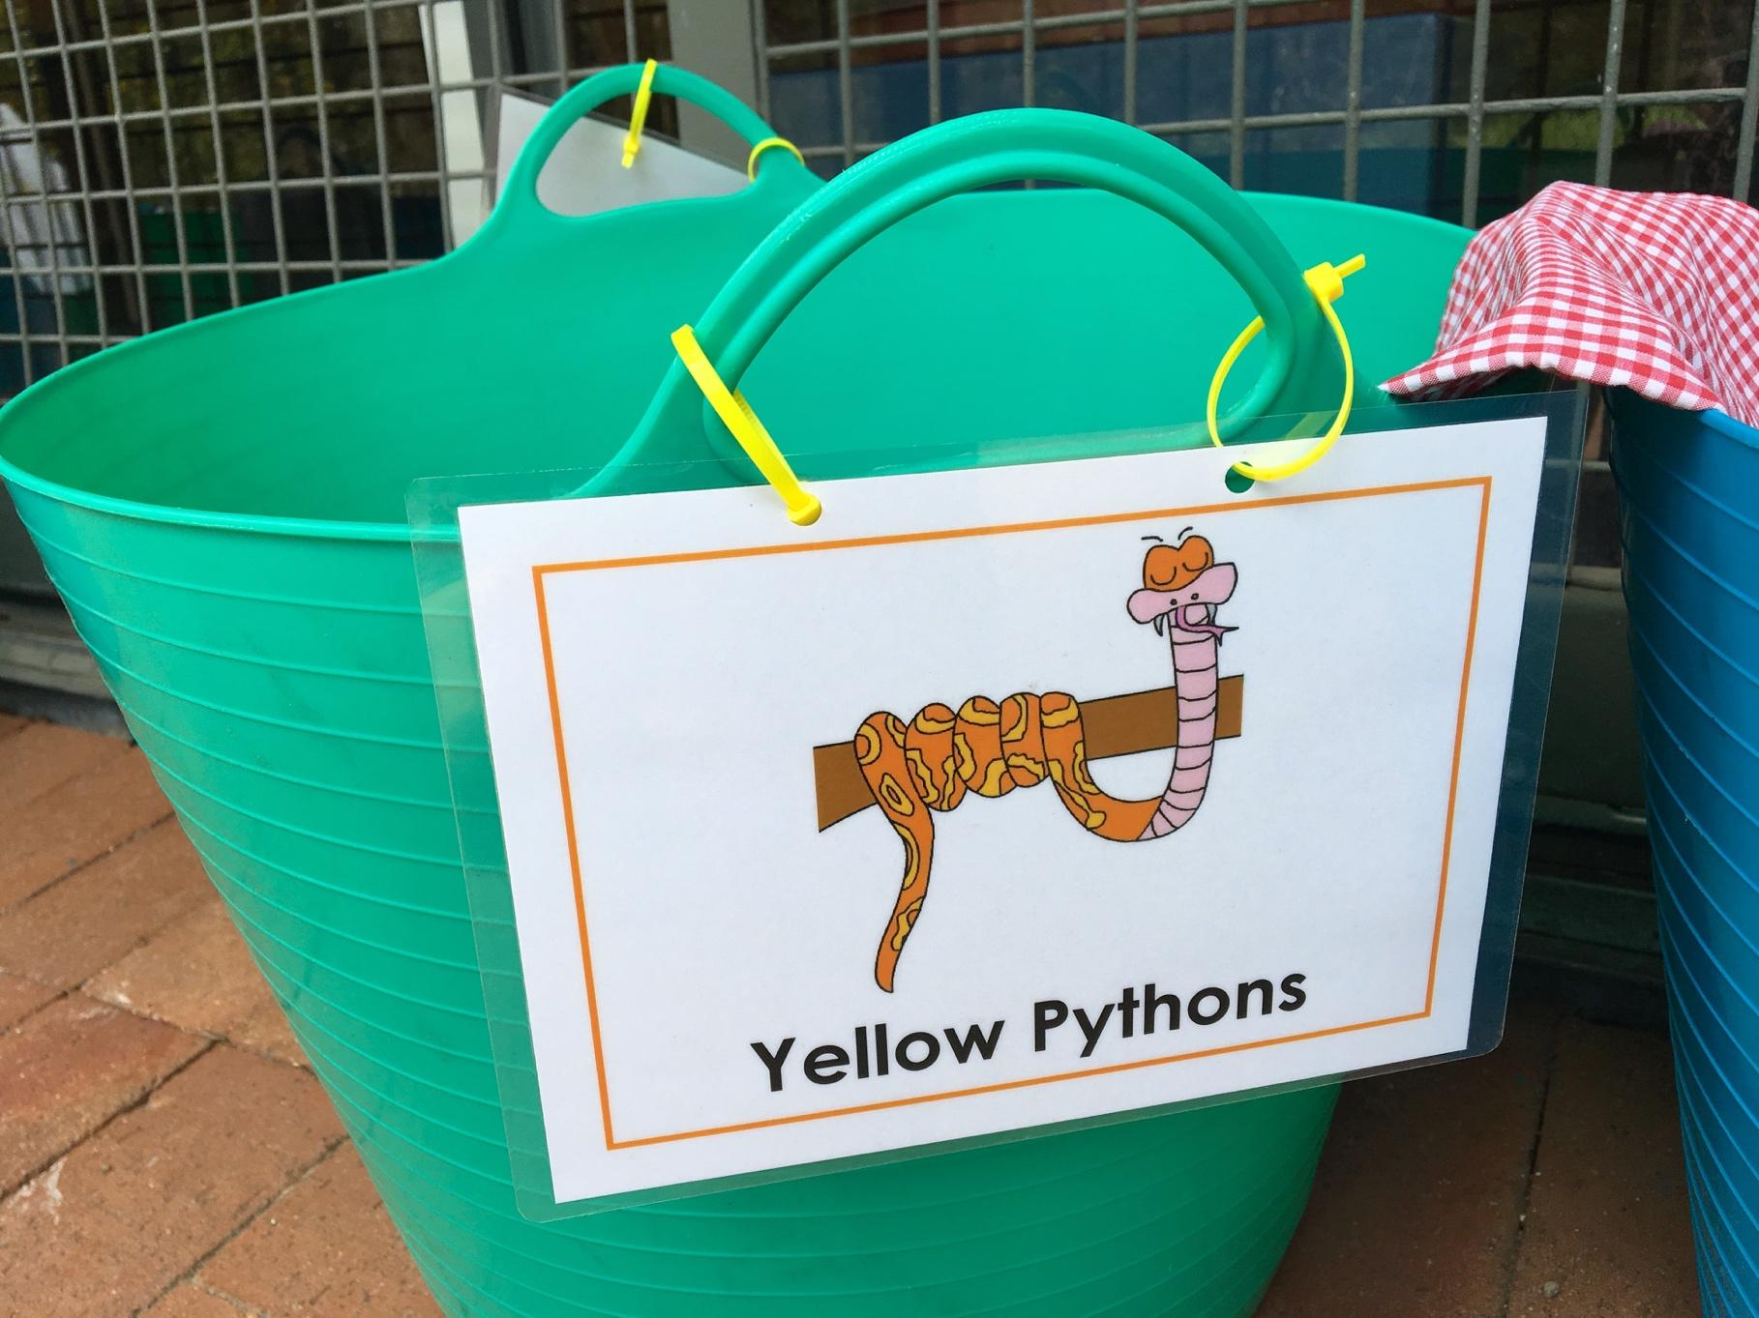
After recess you put your teddy, lunch box and drink into your lunch tub.
You will put your bag onto the bag shelves.
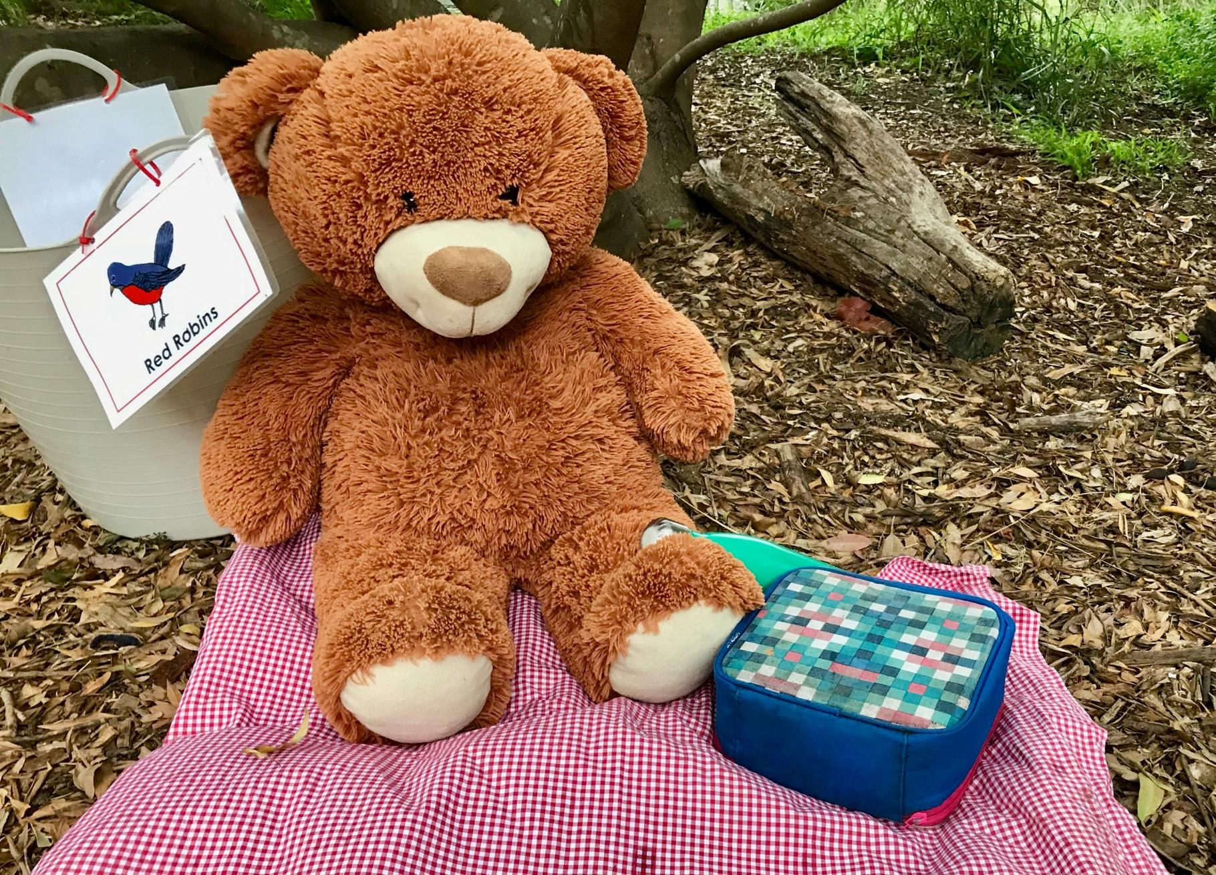
At lunch time you will have a teddy bears picnic.
After eating time you will have a play on the grass.
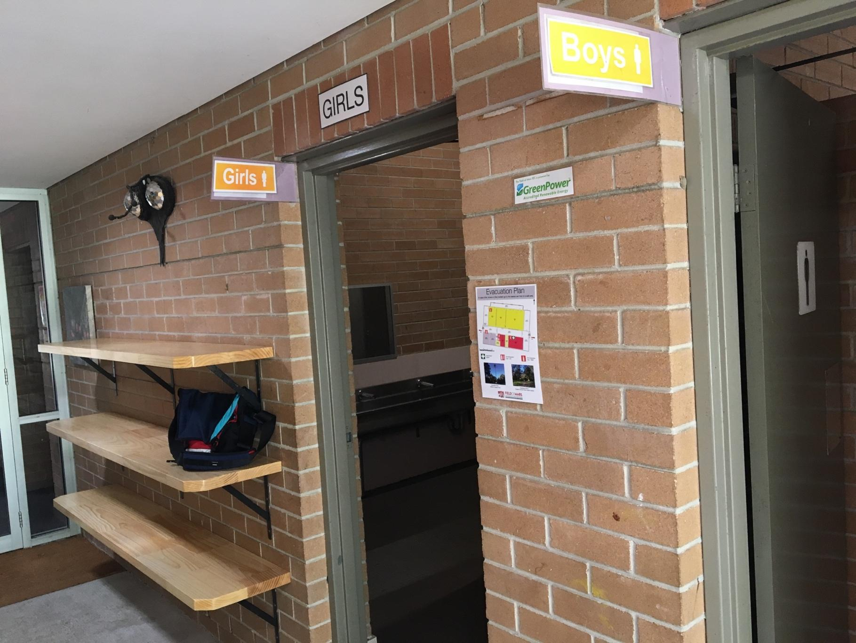
At the end of the day you will go to the toilet and collect your bag.
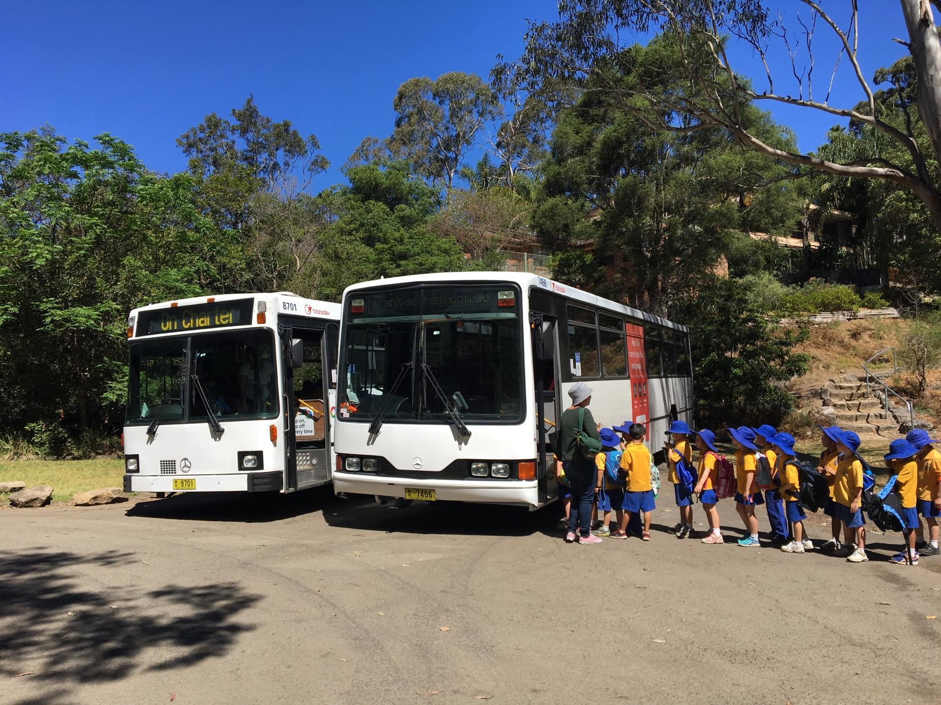
You will walk to the bus and it will take you back to school.

