Social Story

Schoolyard Safari
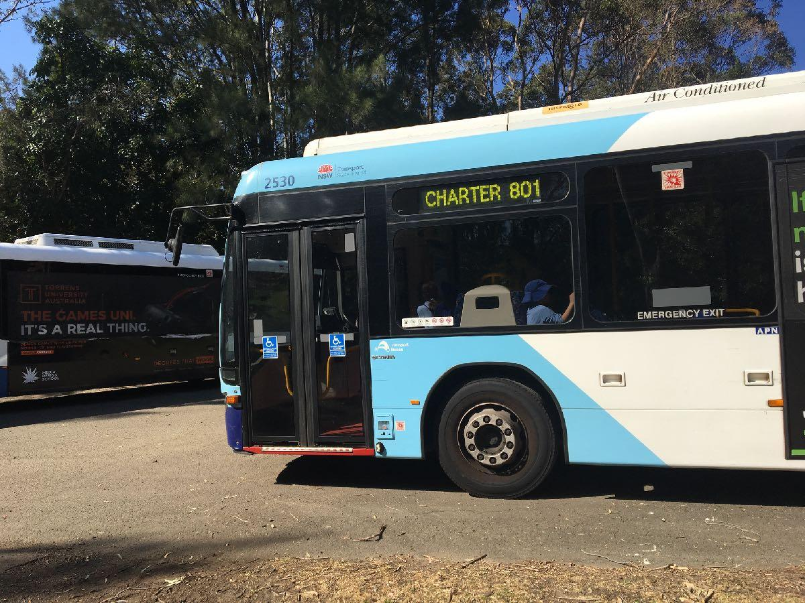
A bus will take you to the Field of Mars Environmental Education Centre.
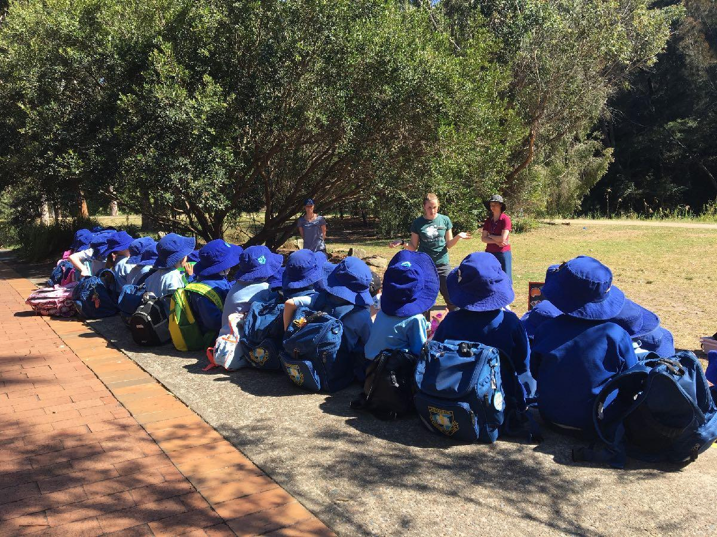
When you arrive, you will sit in the meeting area. The teachers will talk with you about your day.
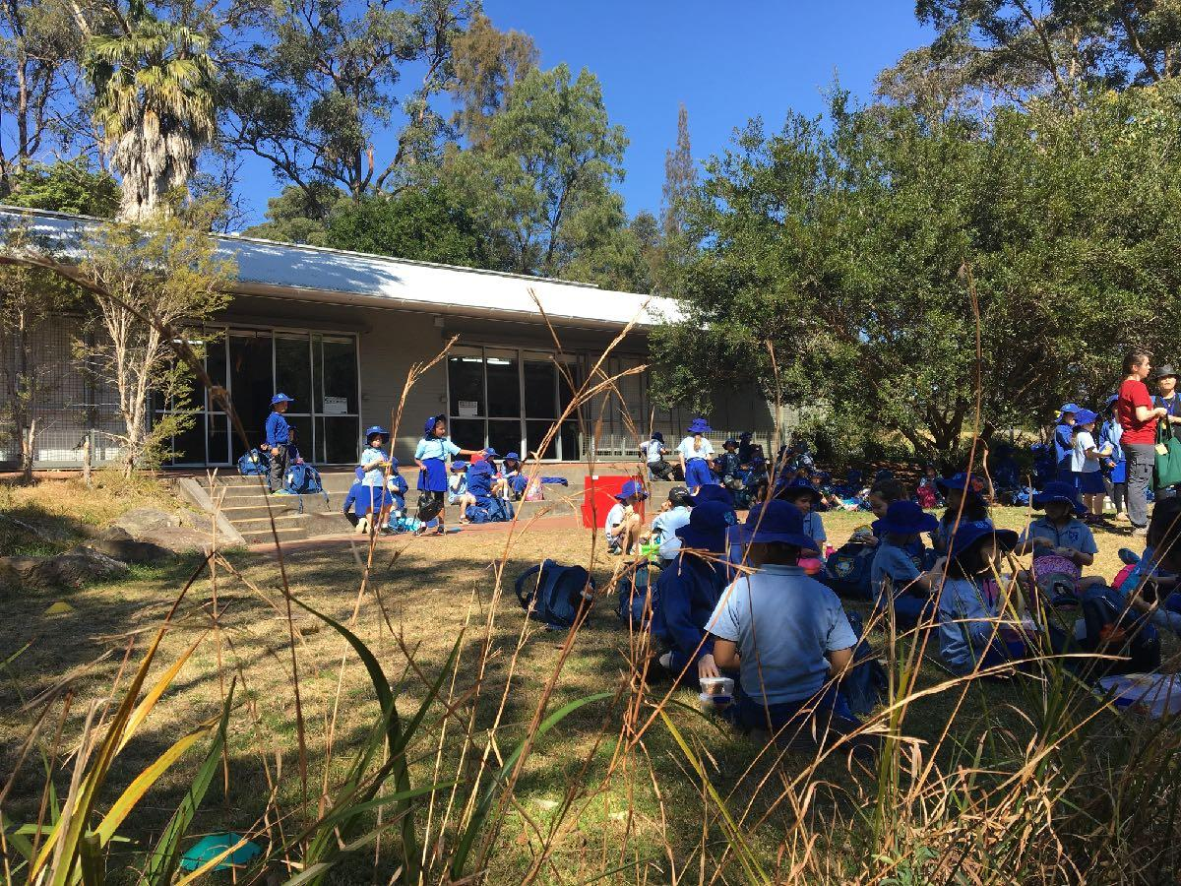
At recess you will sit on the grass beside the classrooms and eat your morning tea.
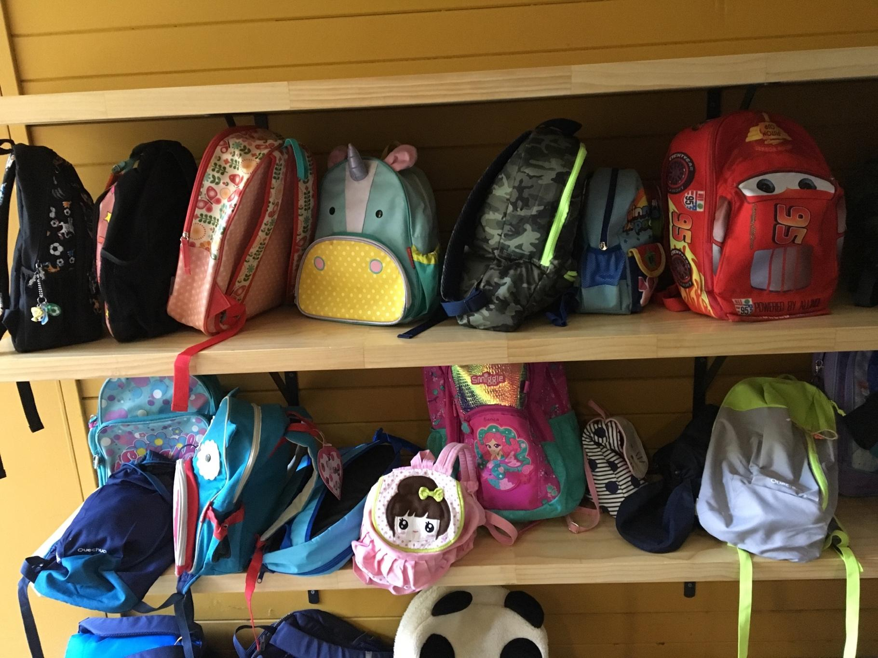
You will put your bag on the shelves. It will be safe there.
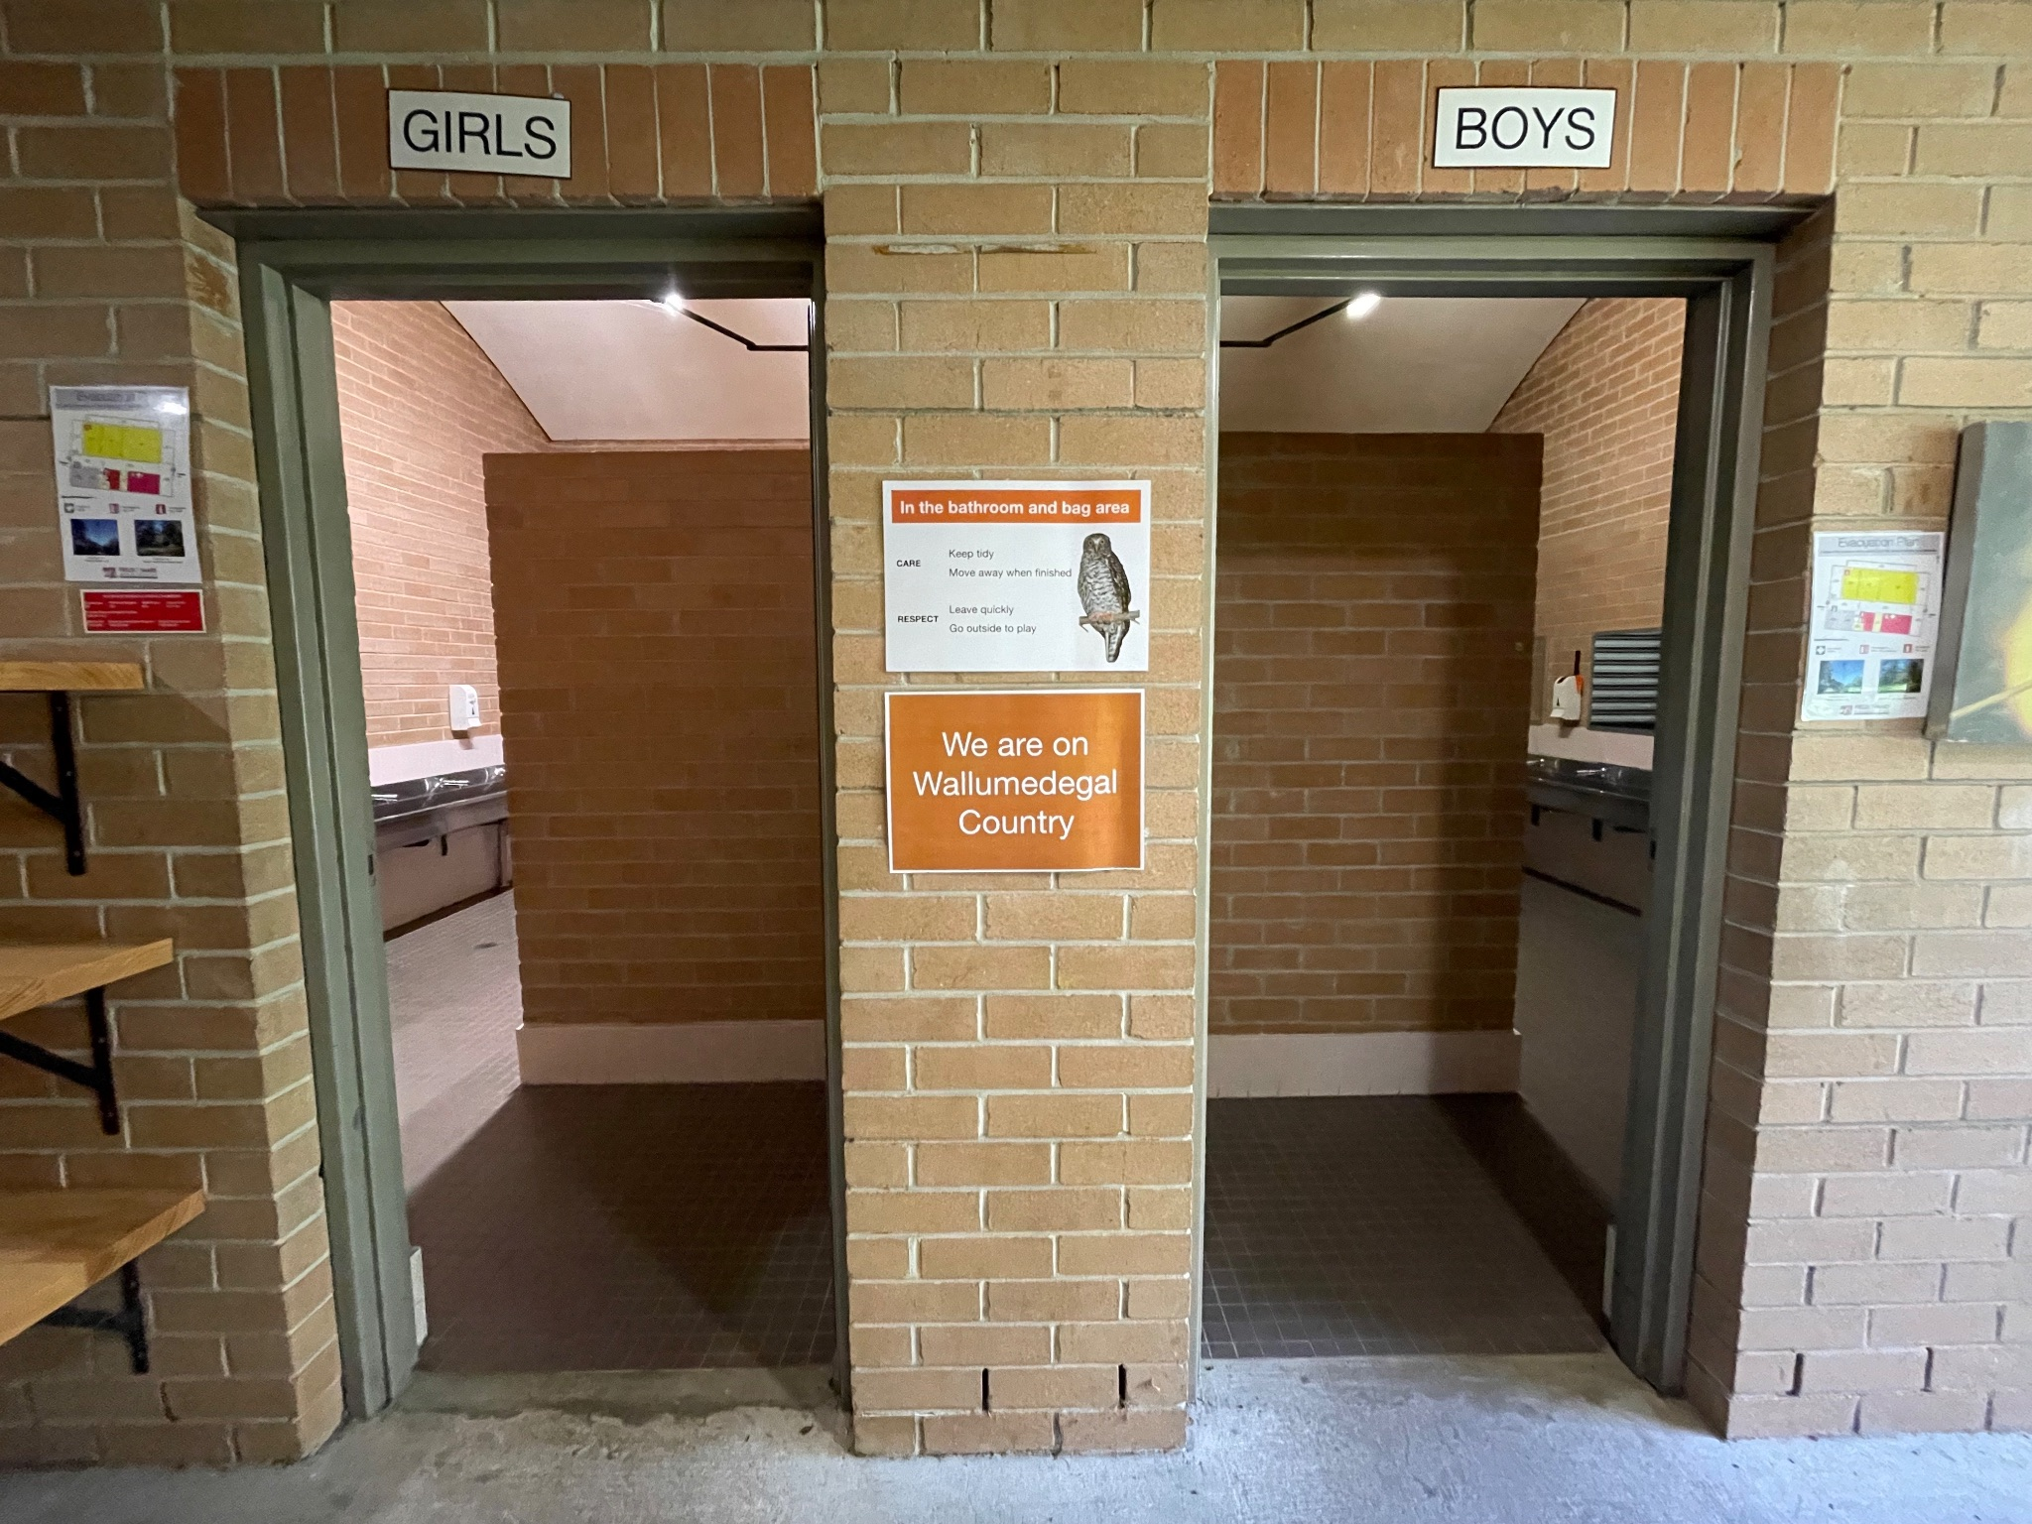
You will go to the toilet before starting the activities.
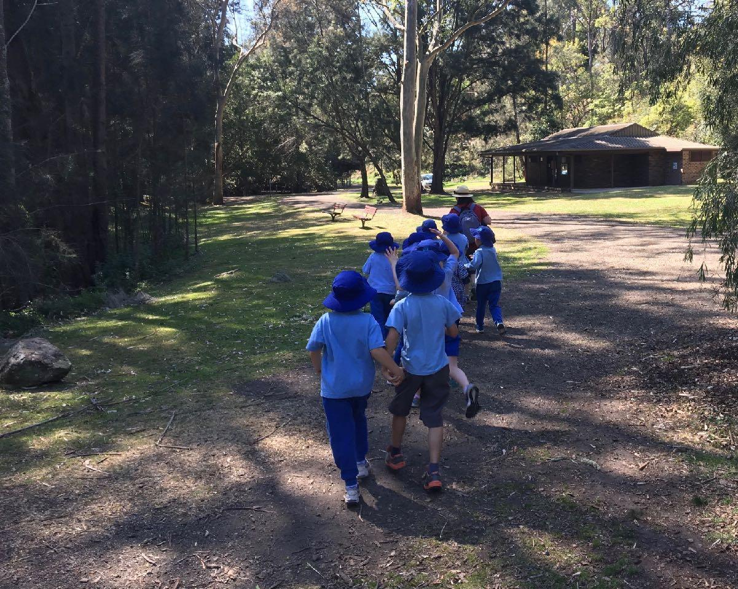
You will go for a bushwalk in the Field of Mars Reserve.
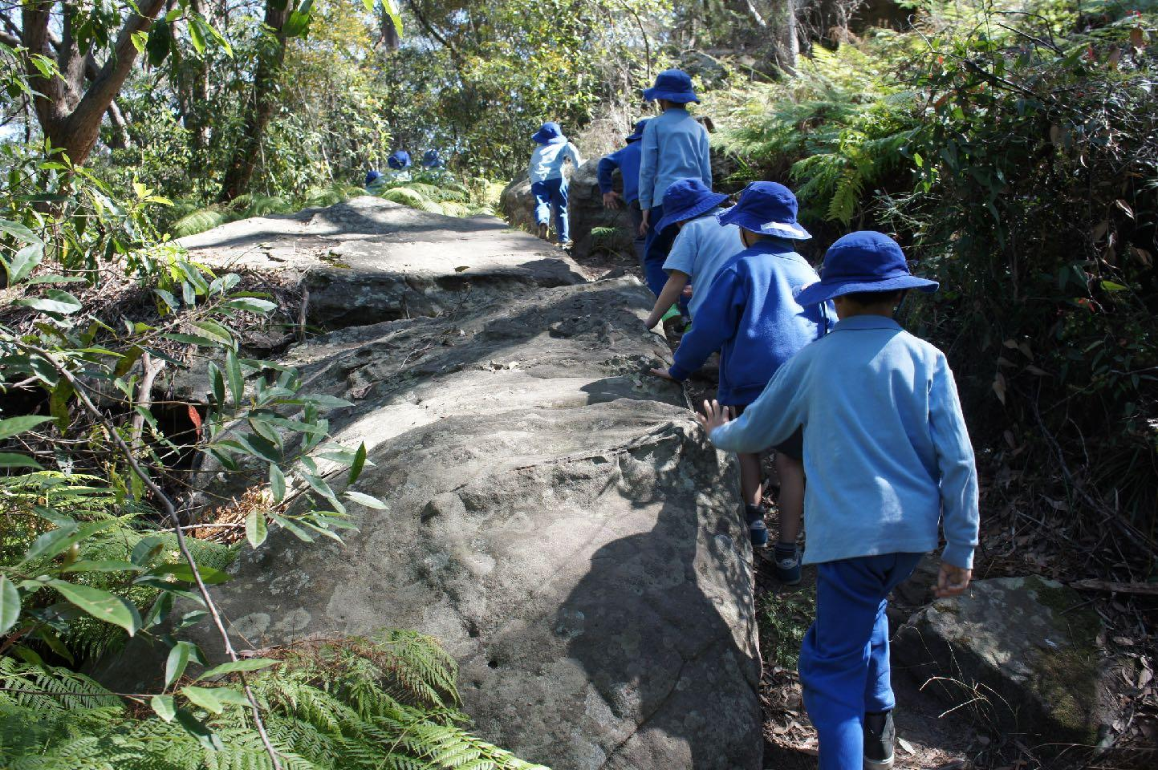
You will explore the bushland environment.
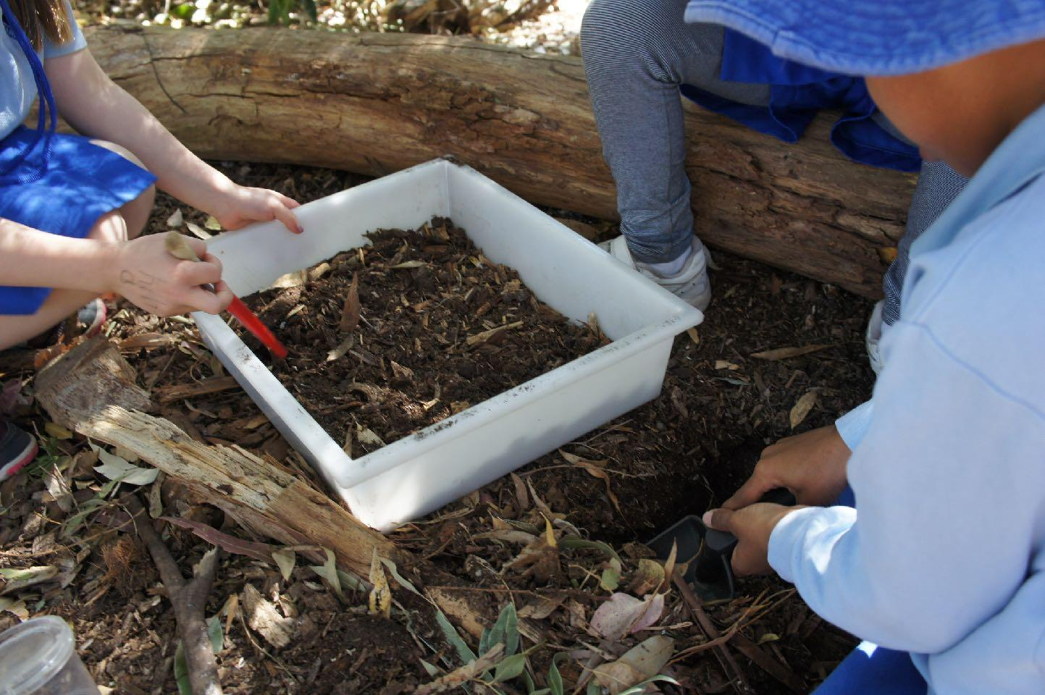
You will use equipment to look for invertebrates in the gardens near the classrooms.
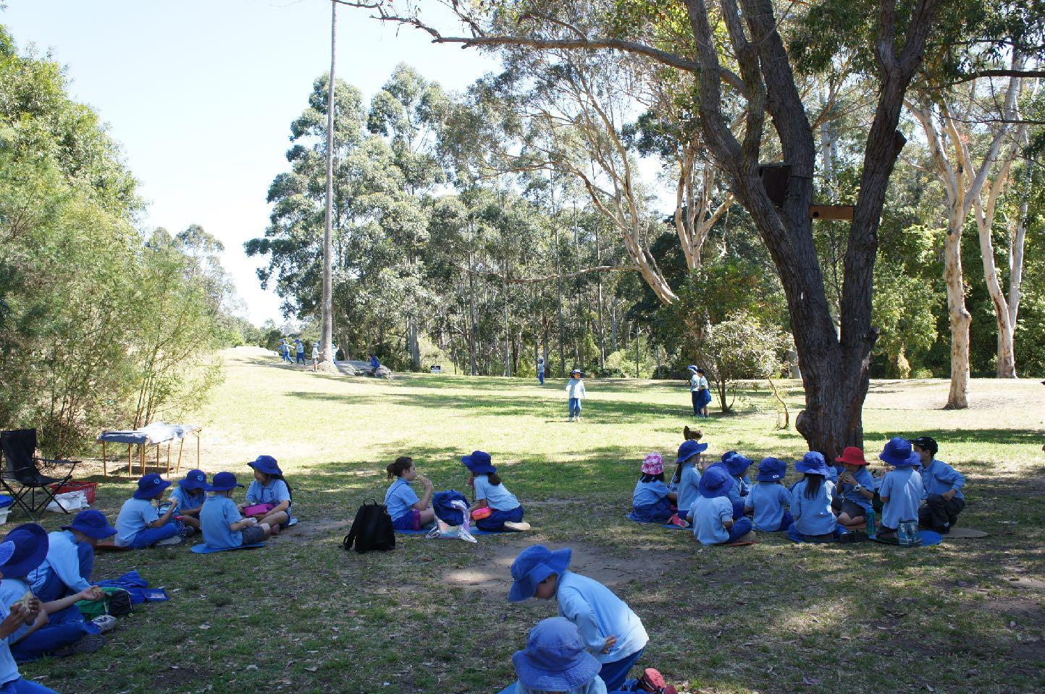
At lunch time you will sit on the grass to eat your lunch.
After eating time you will play on the grass.
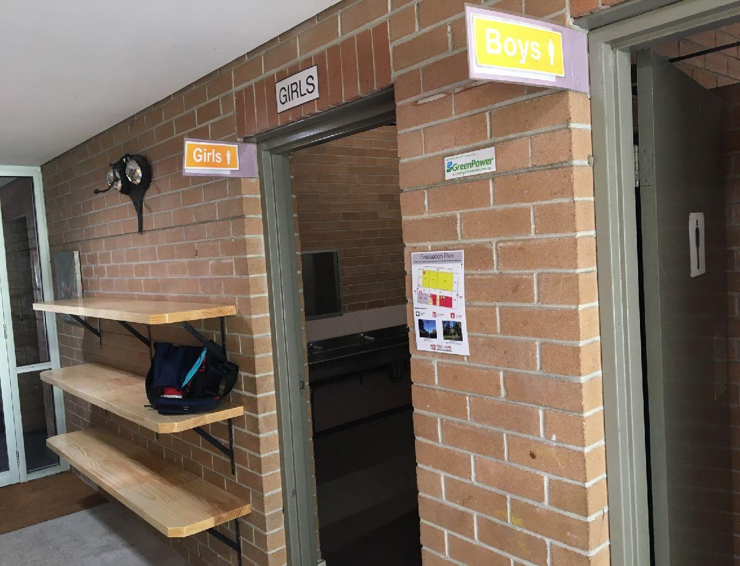
At the end of the day you will go to the toilet and collect your bag.
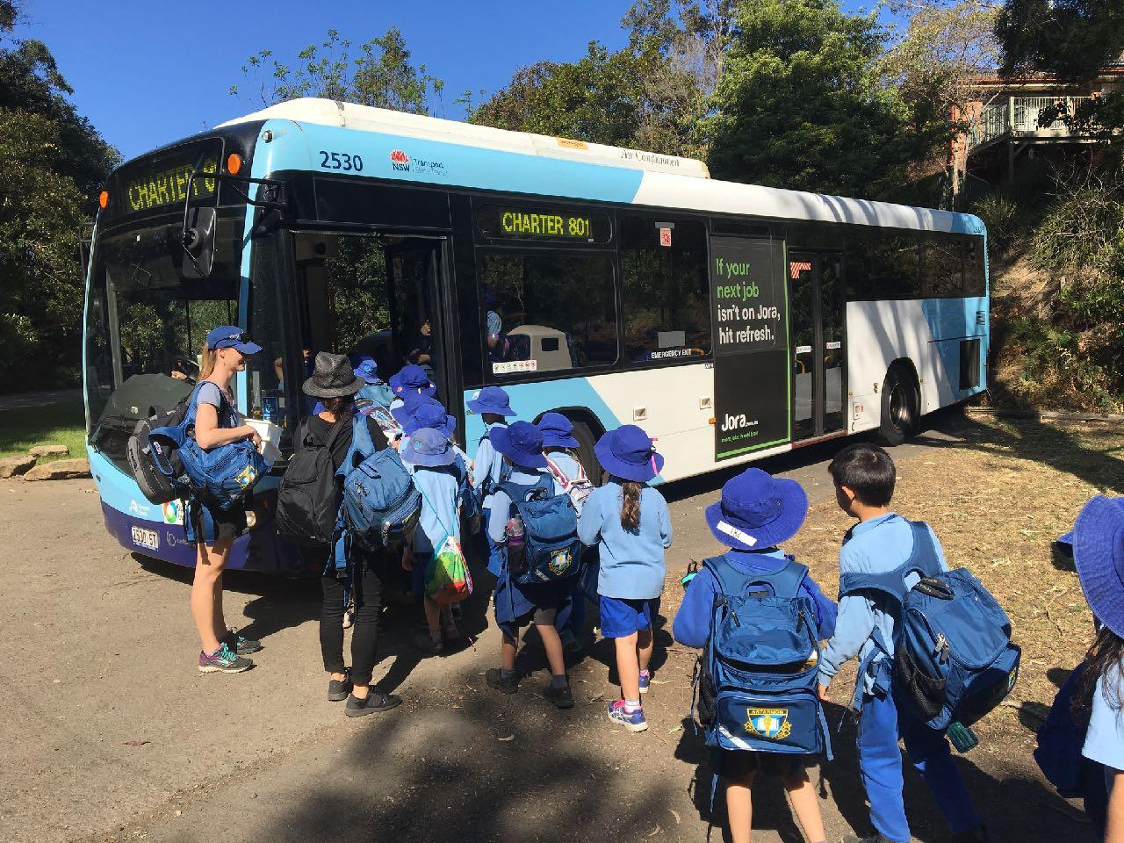
You will walk to the bus and it will take you back to school.

