Social Story

Features of Places
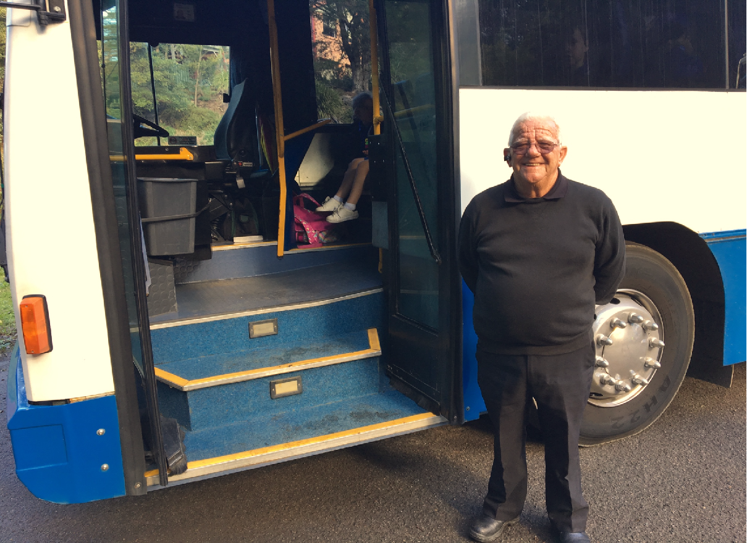
A bus will take you to the Buffalo Creek Reserve.
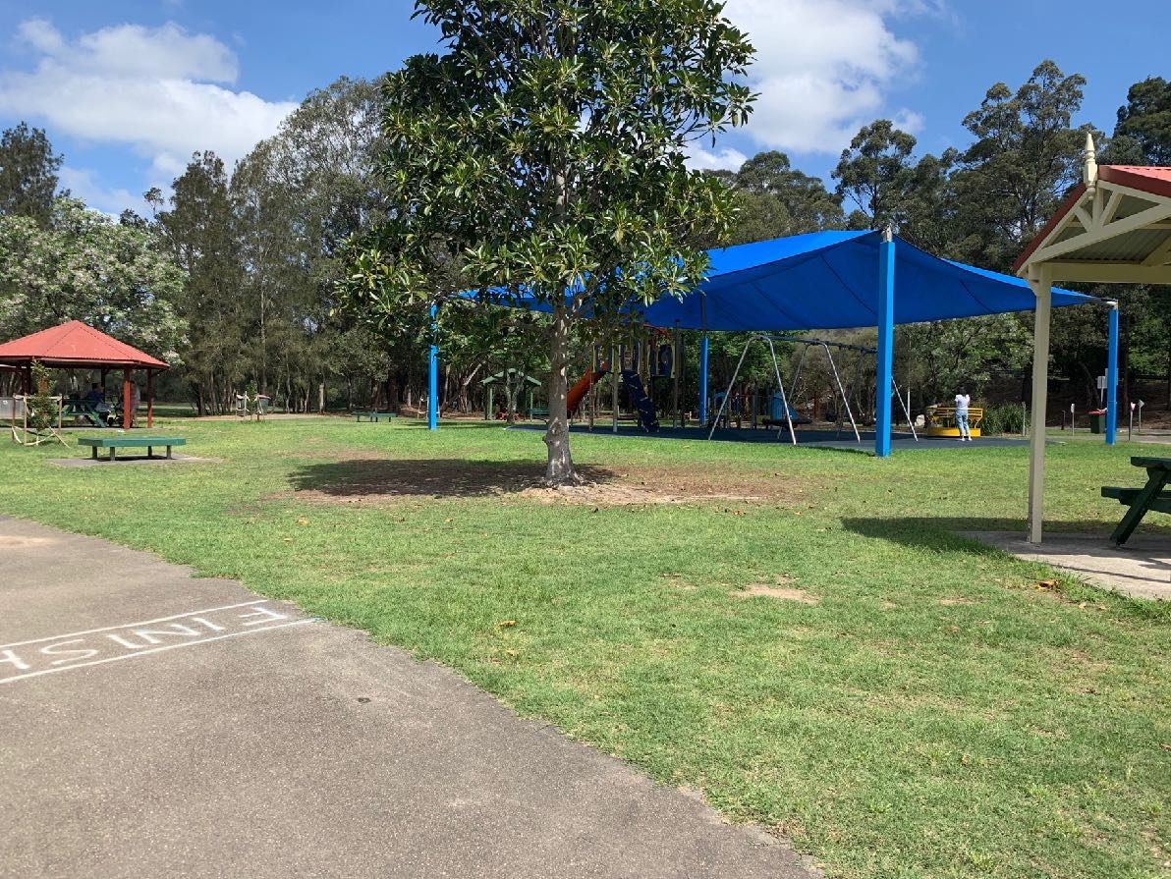
You will walk through the playground at Buffalo Creek Reserve to the meeting area. You will not play on the play equipment.
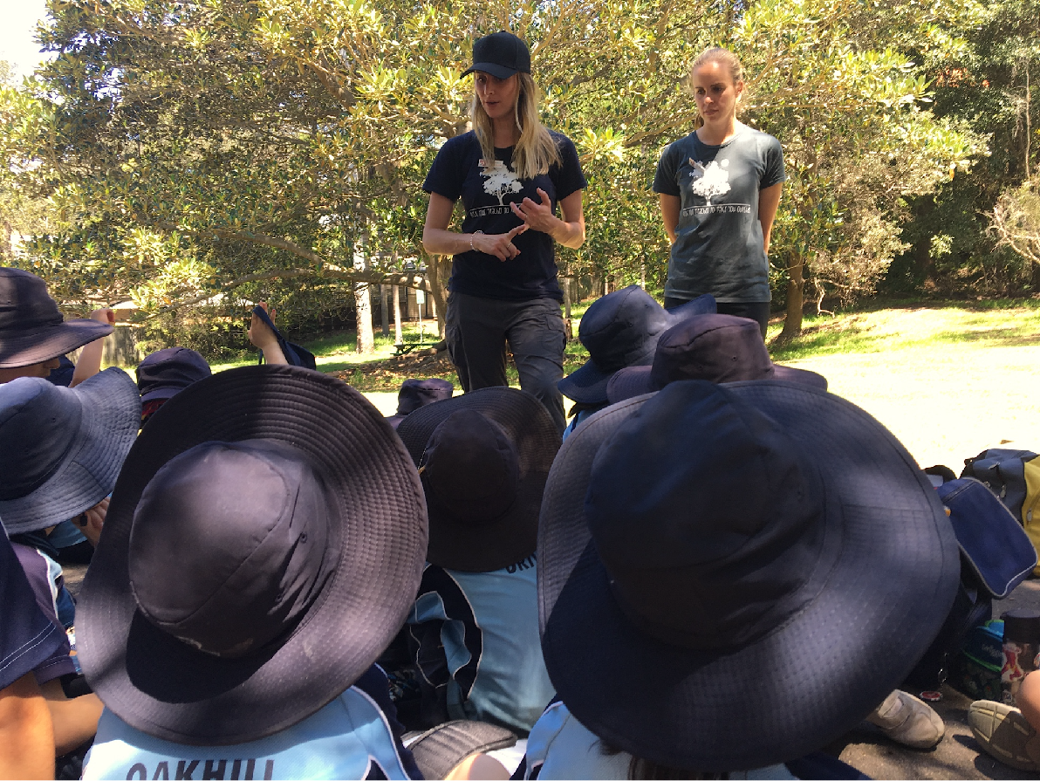
In the meeting area the Field of Mars EEC teachers will talk with you about your day.
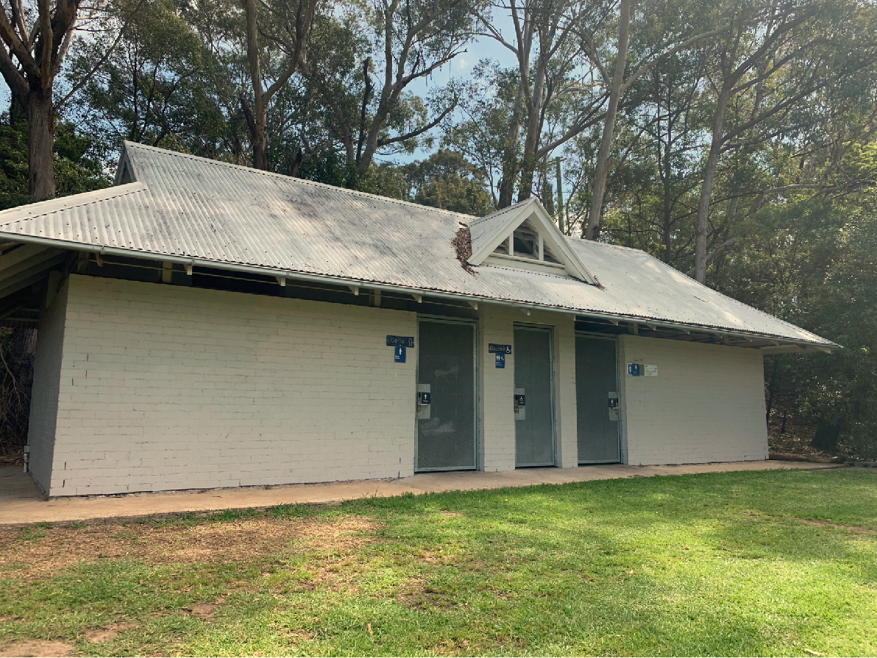
You will go to the toilet and prepare for your day’s adventure.
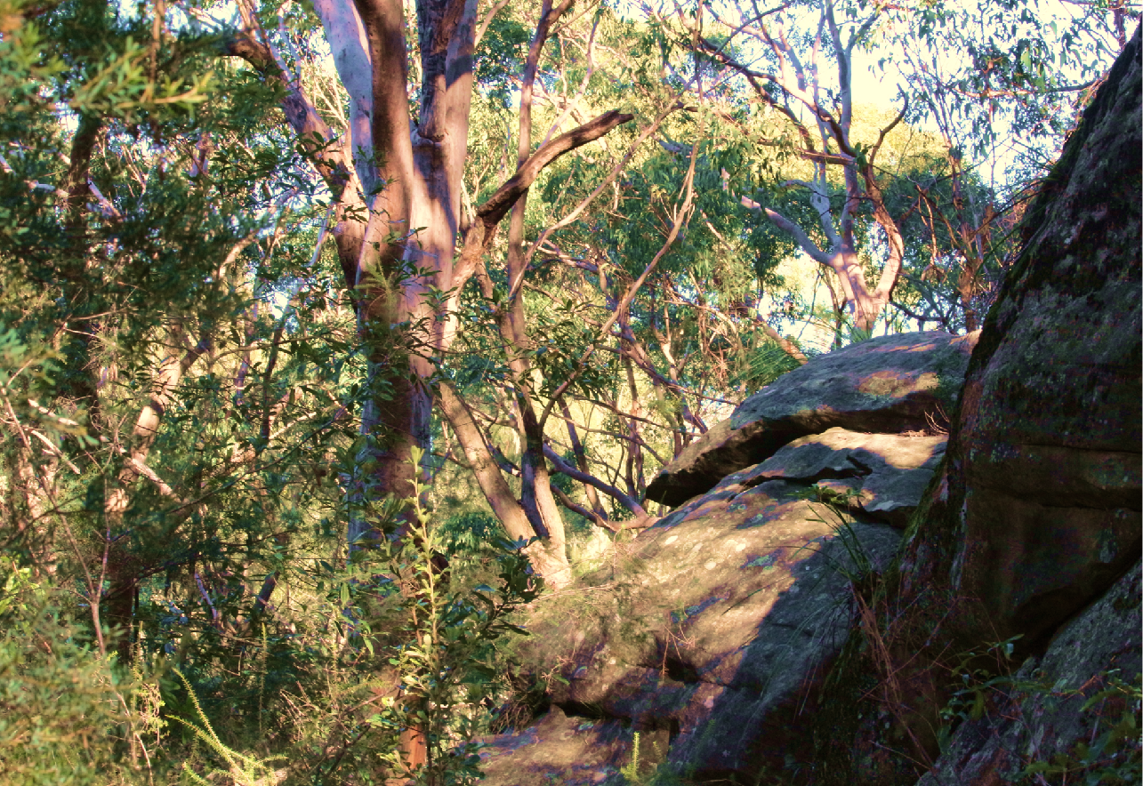
You will go on a bushwalk around the Sugarloaf in Lane Cove National Park to investigate the features of places.
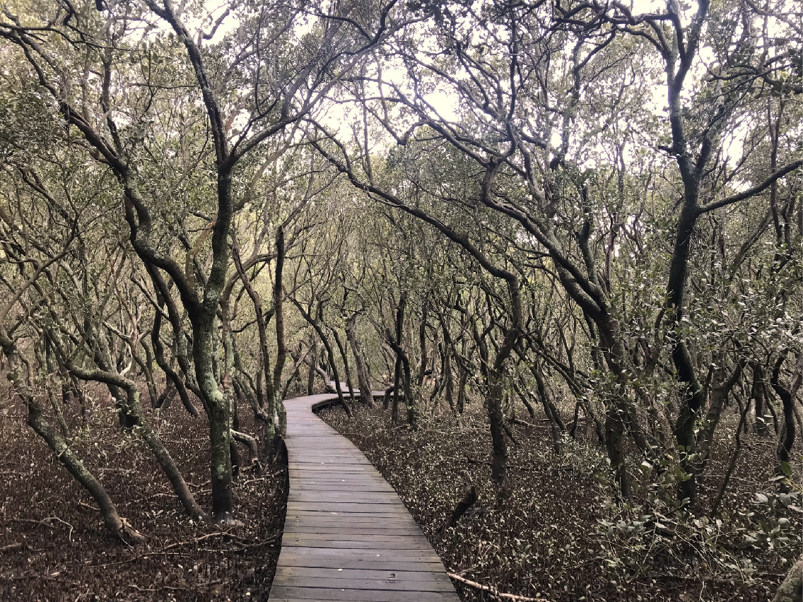
You will walk through the mangrove forest on a boardwalk.
You will then walk on the wooden bridge over Buffalo Creek.
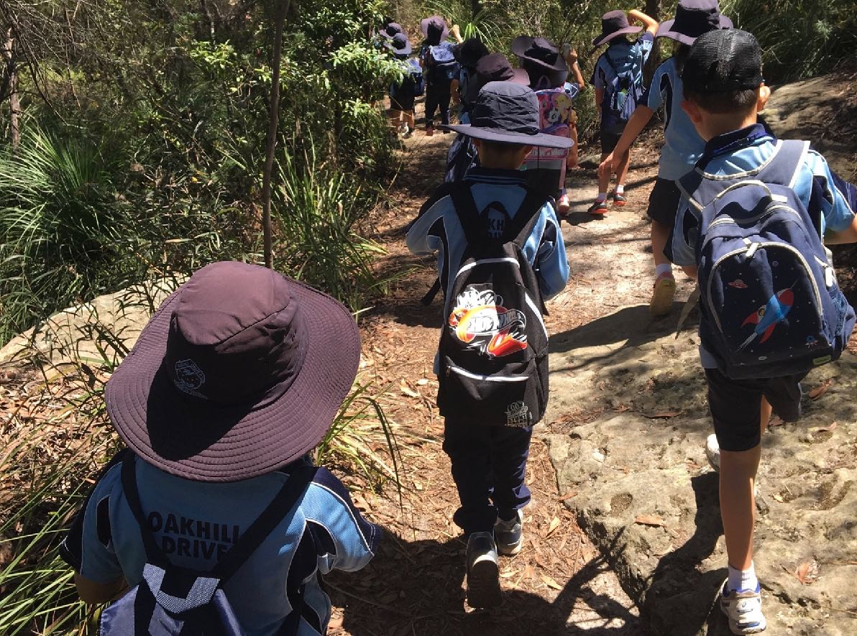
You will walk on bush tracks that have dirt and rocks.
When it has been raining the rocks can be slippery.
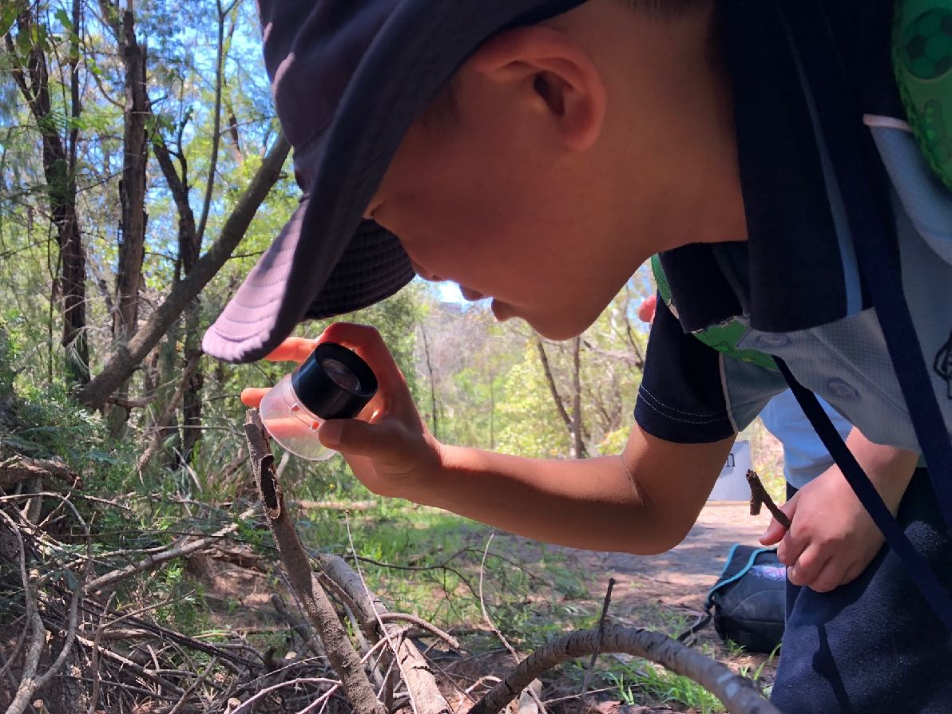
You will look, listen, touch and smell different things in the bushland.
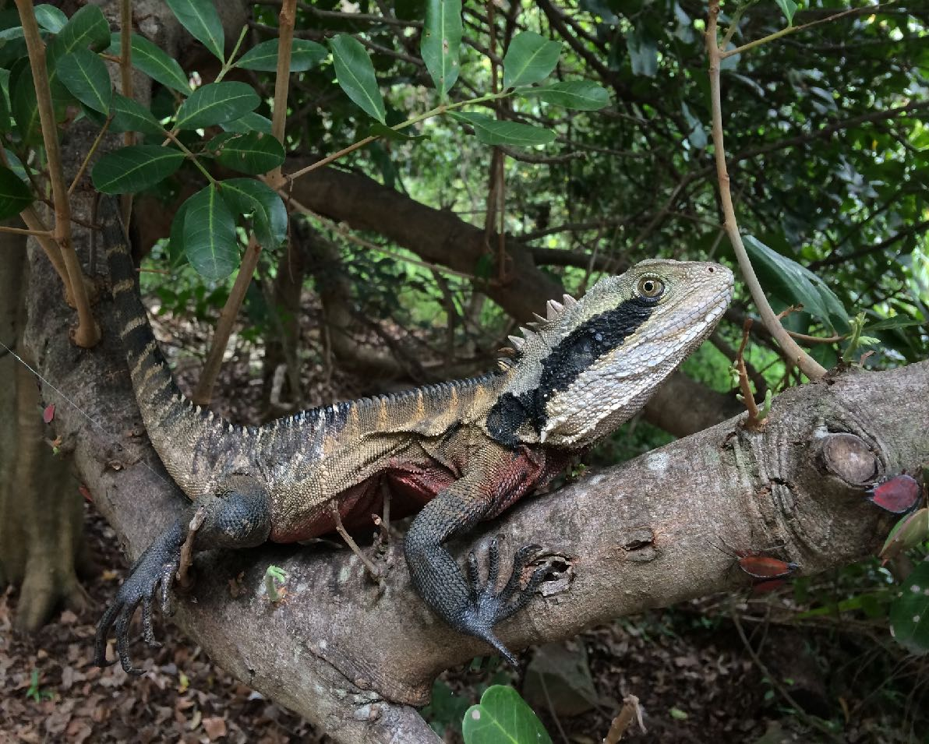
You might see some wildlife that lives in the bushland.
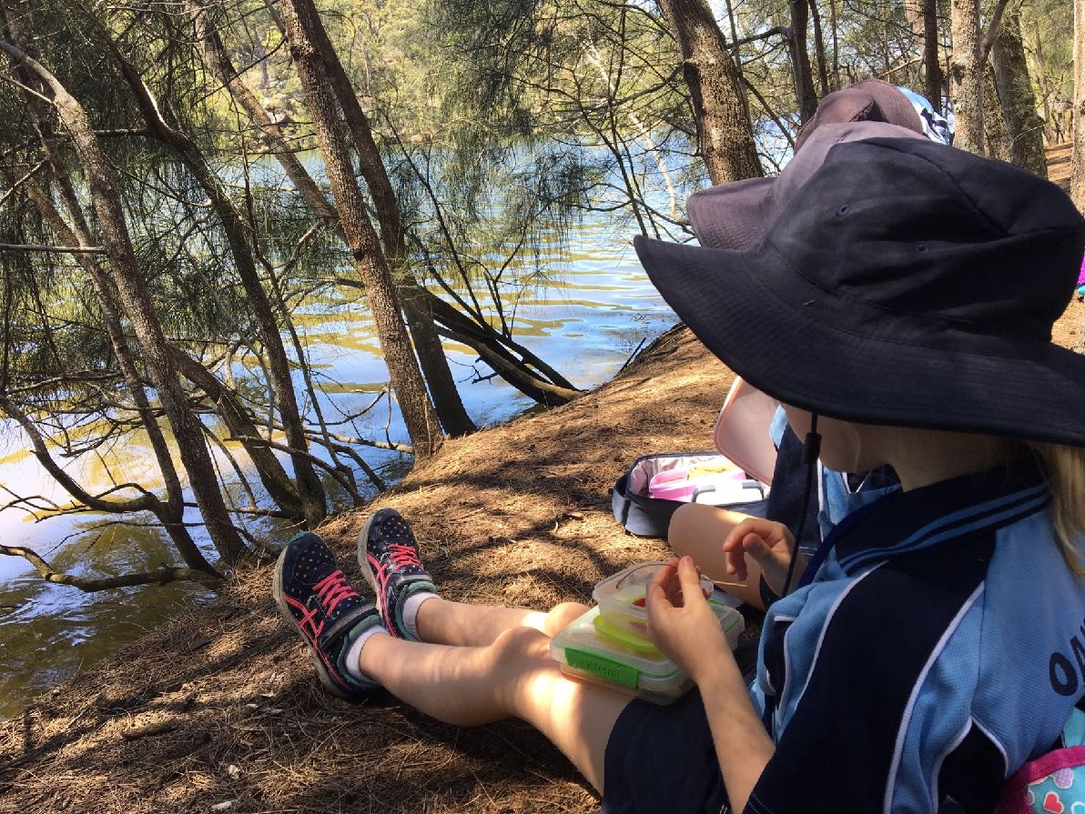
You will have lunch by the Lane Cove River at Sugarloaf Point.
There are no toilets, taps or rubbish bins. Your rubbish will go in your bag.
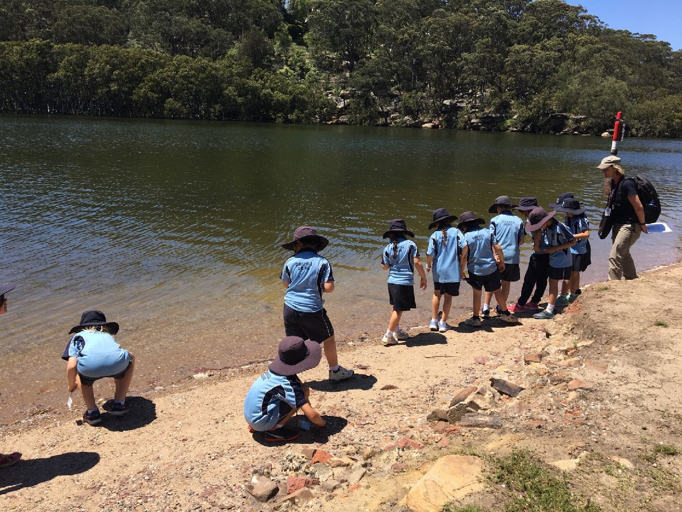
You will explore the riverbank at Sugarloaf Point and look for living things.
You will stay out of the water.
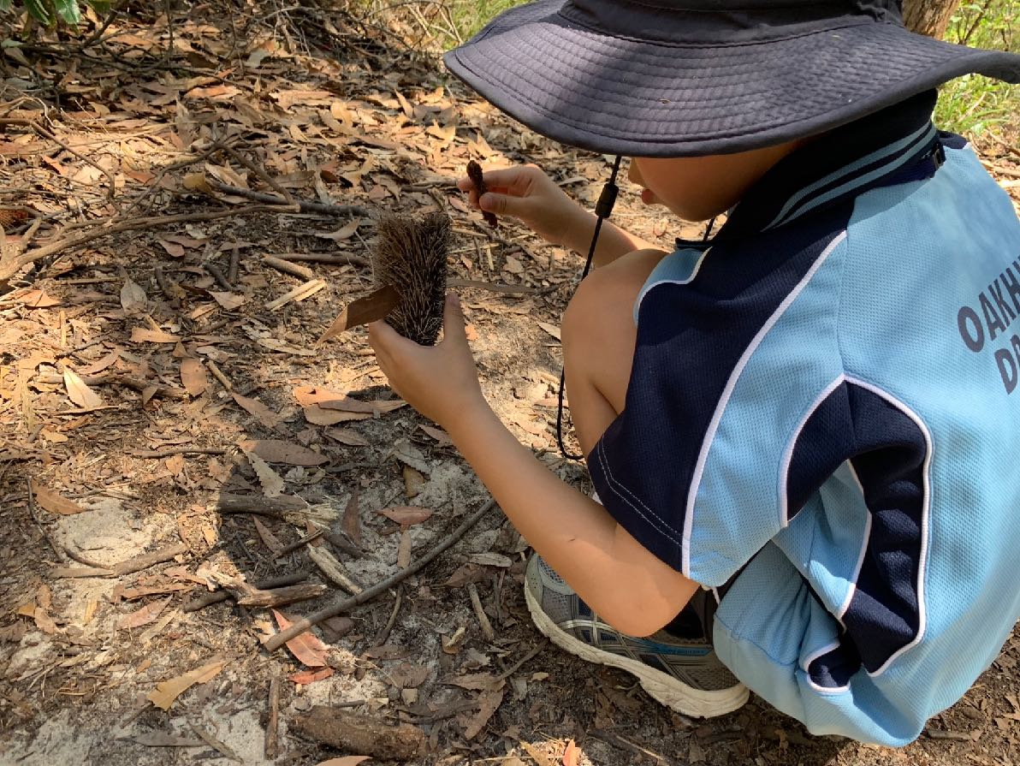
After lunch you will continue your bushwalk to investigate the features of the place.
When you return to Buffalo Creek Reserve you will have a short break.
You will go to the toilet and wash your hands.
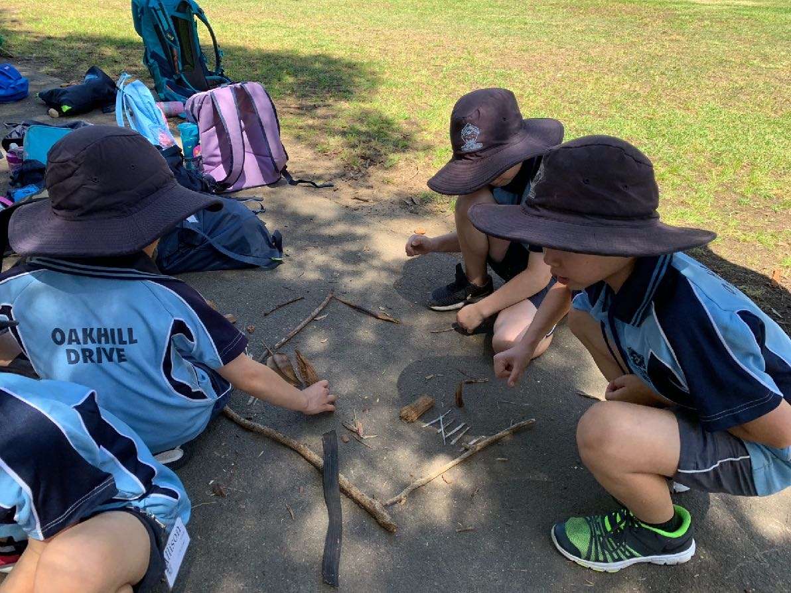
You will use natural materials collected from the ground to create a nature map.
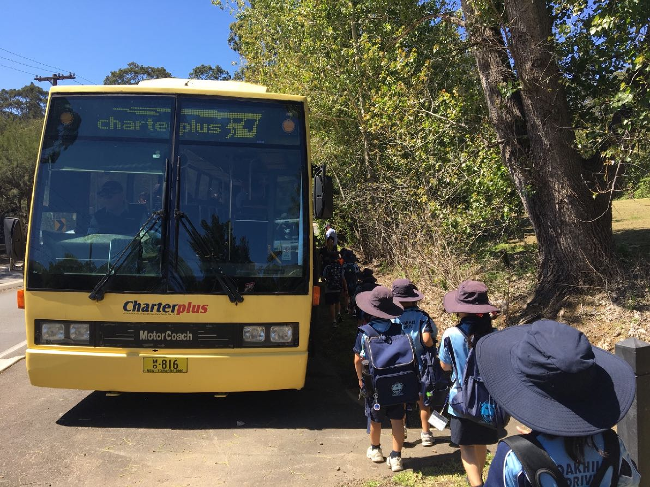
You will walk back to the bus. The bus will take you back to school.

